Digitalization Industrialization Standardization Collaboration

DISC DEXPI

Equinor – Aker BP – Aker Solutions - Aibel
Document title:
DISC DEXPI Transfer Requirements
Document no.: | Rev.: | Page:
 | 5.7 | 1 of 80

DISC DEXPI Transfer Requirements
Prepared for
DISC DEXPI Group
Prepared by
Tonia Pedersen
Revision and Signoff Sheet

Change Record
Revision | Date | Reason for issue, key changes and or decisions | Prepared
5.0 | 18.08.2025 | DEXPI 2.0 references, update added.  Change naming of PrimaryElement. Update Proteus references. | TLP
5.1 | 15.09.2025 | Update to include new DEXPI 1.4 class elements: SensorWell, Mount, TransmissionSystem | TLP
5.2 | 25.09.2025 | Include ProcessSafetyFunction. | TLP
5.3 | 06.10.2025 | Equipment Internals. | TLP
5.4 | 09.10.2025 | Reverted Mount model to simplified instrumentation model. Updated persistent ID table. | TLP
5.5 | 10.11.2025 | Add persistent id info for Transmissionsystem | TLP
5.6 | 17.12.2025 | Removed Proteus references, added Custom Equipment Package & Property Break details. Detailed SignalConveyingFunction line styles. Update details for DEXPI 2.0 as new current standard. Update all model figures to reflect new naming and reference to DEXPI Profile. | TLP
5.7 | 17.12.2025 | Removed references to IsVirtual and Virtual elements – no elements without graphics. | TLP
Technical Advisor
Name | Position | Email
Manfred Theißen | DEXPI technical resource | theissen@plants-and-bytes.de

Table of Contents
DISC DEXPI Transfer Requirements 2
Change Record 3
Table of Contents 5
Overview 7
Purpose 7
Abbreviations 7
References 7
Constraints/Assumptions 8
Process and Instrumentation Diagram Transfer 9
Overview 9
P&ID Transfer Breakdown Grouping 9
P&ID Example C01_NOA1 June MileStone Example 10
DEXPI Standard 11
DEXPI 1.2 -> DEXPI 2.0 updates: 11
Analysis: 11
Transfer Requirements 12
Symbols 13
Persistent ID 17
File & Drawing Metadata 19
Process Plant, Plant System & Plant Area 23
Equipment 25
Equipment Internals 30
Piping 32
Instrumentation 38
Equipment Box 56
Labels 58
Note 59
Miscellaneous Graphics 61
ANNEX A: PipingNetworkSegment topology details 75
ANNEX B: Symbol Rotation and mirroring 77
Rotation and Mirroring Details 78
ANNEX C: Signal conveying Line Types 79
ANNEX D: Valve Label Details 80

Overview

Purpose
This document provides the requirements for the DISC DEXPI project transfer of the P&ID between intelligent engineering systems using the DEXPI 2.0 standard.

Abbreviations

 | Description | Comment
DISC | Digitalization Industrialization Standardization Collaboration
DEXPI | Data Exchange in the Process Industry
P&ID | Process & Instrument Diagram
OPC | Off Page Connector
PIF | ProcessInstrumentFunctions
DEXPI XML | Working name for DEXPI 2.0 serialization format

References
Ref | Document / Standard | Title / Description | Rev
[1] | ISO 15926 | Interoperability standard for process plants
[2] | Z-004 | NORSOK CAD Symbol Libraries
[3] | TR3111 | Equinor LCI Requirements - Data Content and Transfer
[4] | DEXPI | DEXPI P&ID Specification Standard | 2.0
[5] | DISC DEXPI Profile | DISC DEXPI Profile | 1.0
[6] | POSC Caesar Reference Data Library | Reference Data Service (posccaesar.org)

Constraints/Assumptions
The following points indicate general constraints/assumptions made when writing this document that were used to determine the scope and should be referenced when determining the design solution.
- DEXPI 2.0 standard shall be used within the project. **DEXPI 2.0 has uses the same conceptual model as DEXPI 1.4.
- It is required that all parties shall use the same graphical representation and ID of each symbol as defined in the DISC DEXPI Profile (Ref: [5] ). It is vital that dimension, origo/rotation/mirroring point information is correctly defined in the symbol as per the definition.
- DISC DEXPI Symbol Library symbols shall be used as the basis for mapping towards DEXPI class definitions.
- Any Symbol that does not have a match to a DEXPI class definition will be defined with a profile level DEXPI class to provide the type details. POSCCAESAR Ref: [6] will be used as the reference library where possible.
- Each symbol shall be associated with only one DEXPI class element.
- No graphical primitive information shall be transferred when the Symbol Reference ID is provided for the object.
- Current drawing revision number shall be transferred – no historical drawing revision information shall be transferred.
- It is assumed that all main objects; pipelines, equipment, instruments and main piping components shall exist in the target system.
- Assume DEXPI diagram item will always have MinX = 0, MinY = 0, BackgroundColor = “white”
- Project shall assume ‘en’ as the default language for MultiLanguageString types it is therefor not required to transfer ‘Language’ value for these types.
- Equipment box/table shall not be transferred.

Process and Instrumentation Diagram Transfer

Overview
The P&ID is a detailed graphical representation of the process flow and interconnection of the involved components, including piping, equipment, valves, instrumentation, and other process components.
Within the DISC DEXPI project the content of the P&ID has been broken down into the groups shown in the figure below; requirements regarding the transfer of each group are detailed in the sections below with a focus on the C01 example as redrafted by Aibel.
The requirements in this document are focused on the overall modelling structure that shall be used for each of the drafting ‘pattern’ groups defined. Where the modelling structure is supported by the detailed symbol, class, attribute and enumerator definitions provided by the DISC DEXPI profile (Ref: [5] )

P&ID Transfer Breakdown Grouping
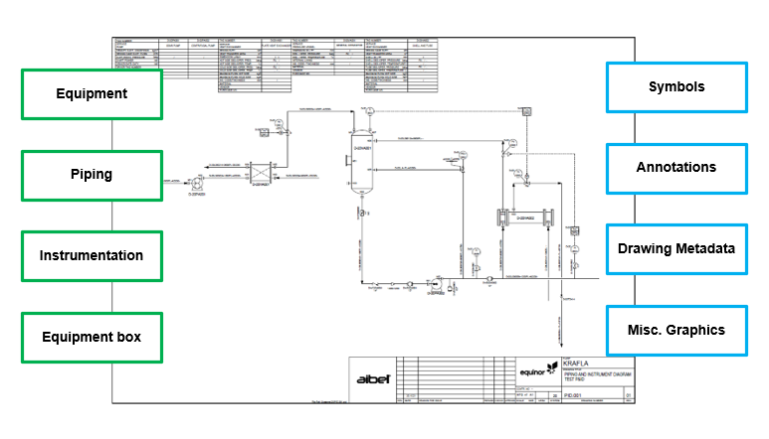
Figure 1: P&ID DISC DEXPI breakdown

P&ID Example C01_NOA1 June MileStone Example
As part of the DEXPI initiative the following example P&ID drawing has been provided. This drawing shall be reproduced in each of the drawing tools as shown in the example below and shall be used as the DEXPI export/import example to demonstrate compliance with the June 2022 milestone requirements.
All symbols shall be shown in the rotation, placement, naming and label placement as below.
**Note: colour has been used to indicate instrument bubbles used for labels (black) vs field instruments (green). Colour information is NOT required in the DEXPI transfer or example file details.

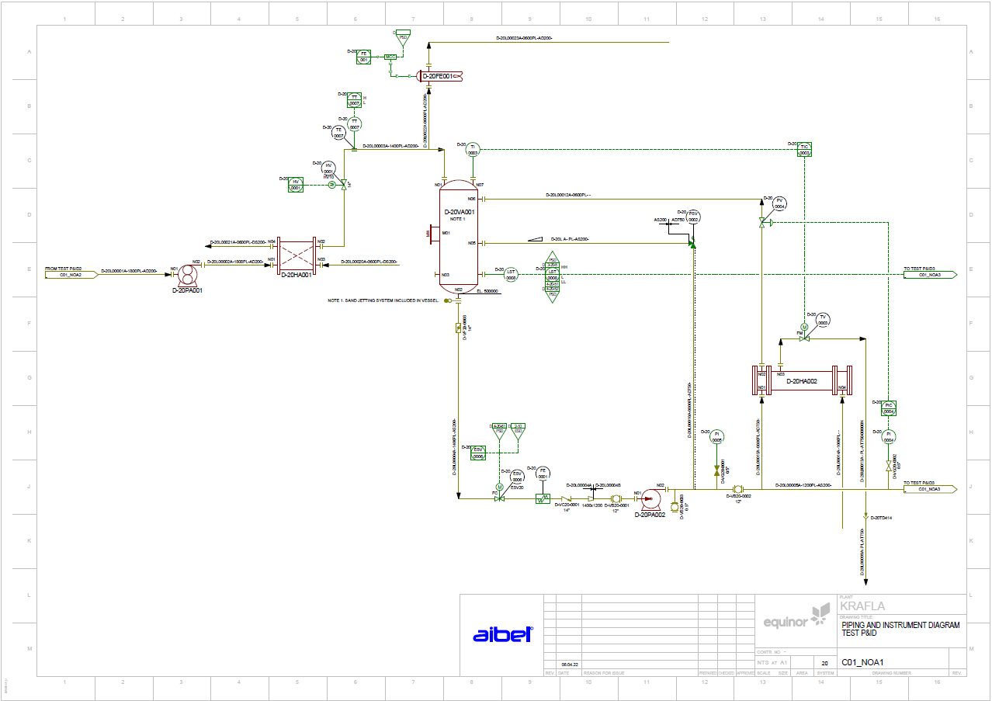
Figure 2: Example C01_NOA1 (June milestone)

DEXPI Standard
The DEXPI P&ID Specification defines an information model for P&IDs as well as a mapping to the exchange format. The current version of DEXPI P&ID 2.0 is serialized using the DEXPI XML Schema with a current working title ‘DEXPI XML’.
**Note: DEXPI 2.0 and DEXPI 1.4 have the same conceptual model.
This transfer requirements document provides all transfer and configuration details based on the DEXPI 1.4/2.0 conceptual model.

DEXPI 1.2 -> DEXPI 2.0 updates:
The DISC DEXPI project was originally based on DEXPI 1.2 for the requirements definition. The current requirements document, however, is aligned with the DEXPI 1.4/2.0 conceptual model. Accordingly, the principal differences between versions 1.2 and 1.4/2.0 are identified and summarized below:
Changes to the DEXPI standard from 1.2 to 1.4/2.0 include these relevant items:
- Units of measurement cleaned up
- More comprehensive specification of graphics
- PropertyBreak class changed to PipingNetworkSegmentItem subtype
- Introduction of CustomClass and CustomAttribute elements
- Introduction of TransmissionSystem / TransmissionDriver to model link between motors and equipment
- Addition of:
  - Note class type
  - Mount class type
  - AccessNozzle subtype
  - Sensorwell class type
- Renaming of:
  - CustomInlinePrimaryElement -> CustomInlineMeasuringElement
  - ConceptualModel -> PlantModel
  - DEXPIModel -> EngineeringModel

Analysis:
Analysis of the DEXPI 2.0 conceptual model and the DEXPI XML serialization format show that weaknesses identified in the earlier project using DEXPI 1.3 have been addressed.
These weaknesses included:
Engineering Notes not part of the conceptual model: Note class is now part of the new conceptual model.
Object Symbol References restricted to one symbol reference per object: new serialization format supports multiple symbol references.
Offline signal references and multifile support: new serialization format supports multiple file transfer. However, the DEXPI 2.0 conceptual model for multiple file transfer support is still under discussion for the best way forward. A new way forward must be found to model off-page connector types as the current model creates inconsistencies when used across multiple drawings and these drawings are contained within the same information model.

Transfer Requirements
Within the DISC DEXPI project it has been decided that the symbols shall form the basis of the mapping toward DEXPI to support the initial decision that we shall only transfer the graphical information from the P&ID in the DEXPI transfer file.
The DISC DEXPI project requires that each equipment object displayed on the P&ID shall be transferred within the DEXPI format with the required class mapping, symbol reference ID mapping, attribute mapping and association references to the piping / instrumentation systems as shown on the P&ID. The following sections provide details for the class and attribute mapping and implementation of the standard to reflect DISC process engineering drafting standards and symbols. Any additional rules or assumptions to be applied will also be noted in these sections.
General Requirement Details:
- PersistentID referencing shall be used to uniquely identify each class object. The context given within the PersistentID shall include a reference to the exporting application.
- Custom attributes are now defined within the profile and require no additional grouping or definition settings as were required in DEXPI 1.4.
- Custom class elements are now defined within the profile and require no additional definition settings as were required in DEXPI 1.4.

Symbols
The DISC DEXPI symbol legend is based on Z004 NORSOK standard with some additions to support the DEXPI transfer, this project symbol legend is referred to as the DISC DEXPI symbol legend.
All symbols within this legend are mapped to a corresponding DEXPI class definition including any additional attributes to support the definition of the object.
A key feature of the DISC DEXPI symbol legend is the addition of a defined origo point for all symbols and the inclusion of the label as part of the overall graphic. A standard origo point definition across DISC will ensure correct placement of the symbol based on a single point element (x,y) for the shape in the transfer file.
The origo point placement is based on a few general rules:
- In-line components with 2 connectors the origo is placed on the center of the line transecting the symbol along the plane of the to-be connected pipeline to ensure ease of rotation on the pipeline and ease of substitution for intelligent attribute-based symbols.
- In-line components with 3 or 4 connectors the origo is placed at the intersection point of the connectors
- In-line components with 1 connection point the origo is placed at the connection point
 |  |  |  |  |  |  |  |  | Label Details | Label Attribute(s) | Options
DEXPI ID | Graphic | Description | Rotation | Mirroring | ResizingX | ResizingY | TR1970 | Z004 | Symbol | A | 1
ND0011 | 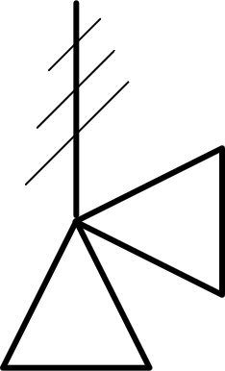 | Spring Actuated Safety Valve | Yes | Yes | No | No |  |  | IM005A
PV019A |  | Valve Ball | Yes | Yes | No | No | STLV008 | PV019A |  | <ObjectDisplayName> | ValvePosition = 'NC'

Requirement Details:
- All symbol definitions are defined within the DISC DEXPI Profile. Symbol definitions include the graphical representation, origo point as 0,0 point, label definitions with associated DEXPI attribute usage within the symbol. A number of symbol definitions also include connection node positions and types (Auxilliary/Instrumentation/Label/Piping); these will be validated against the modelled connections.
- Link between the type element and the Profile symbol shall be through the Diagram model ‘References/Symbol’ for the symbol and ‘References/Represents’ for the element.
- Location of the instance shall be given by the SymbolUsage (Position / Point) attributes for X & Y axiis. The X & Y points are the location reference to the origo of the symbol as defined in the symbol library for the project.
- Transformation definition for the symbol shall use the definitions and rules as defined within the DEXPI standard. Although any rotation shall be allowed and possible to transfer in the DEXPI file it is preferrable that only 0,90,180 & 270 deg anti-clockwise rotation of the symbol is used.
  - X-axis mirroring is provided for within DEXPI through the combination of attributes: ‘IsMirrored=True’ and ‘Rotation=180.0’ as per example (Ref: ANNEX B: Symbol Rotation and mirroring)
- Target application shall apply functionality to ensure that any text given as part of the overall symbol is displayed from left-to-right or bottom-to-top based on the rotation of the graphic.
- Target application shall use the rotation values from the transfer file and interpret the information to ensure graphical best fit with a focus on ensuring any symbol rotation transferred can be imported and displayed.
- All connection points shall be on the grid. This will ensure correct placement and management of the drawing connections for import.
- Symbol scaling shall be given by the ScaleX and ScaleY attribute of the DEXPI ShapeUsage element

DEXPI Model Examples

DEXPI implementation: Symbol references

DEXPI definition
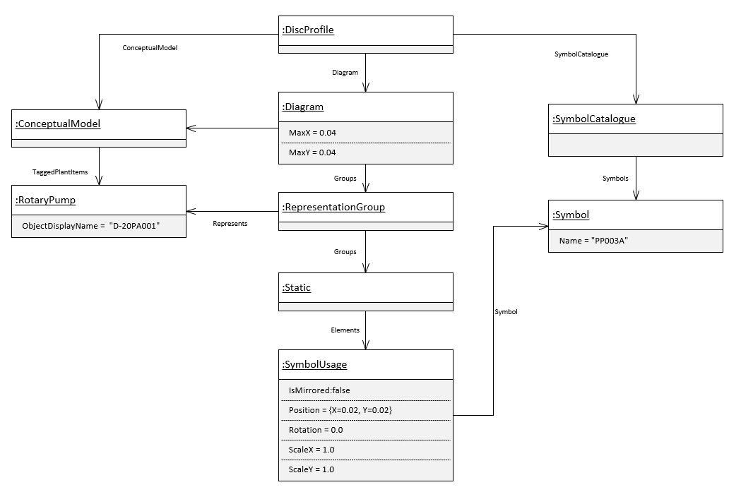
Figure 3: DISC DEXPI symbol usage

DEXPI Model: Shape with label symbol
DEXPI definition
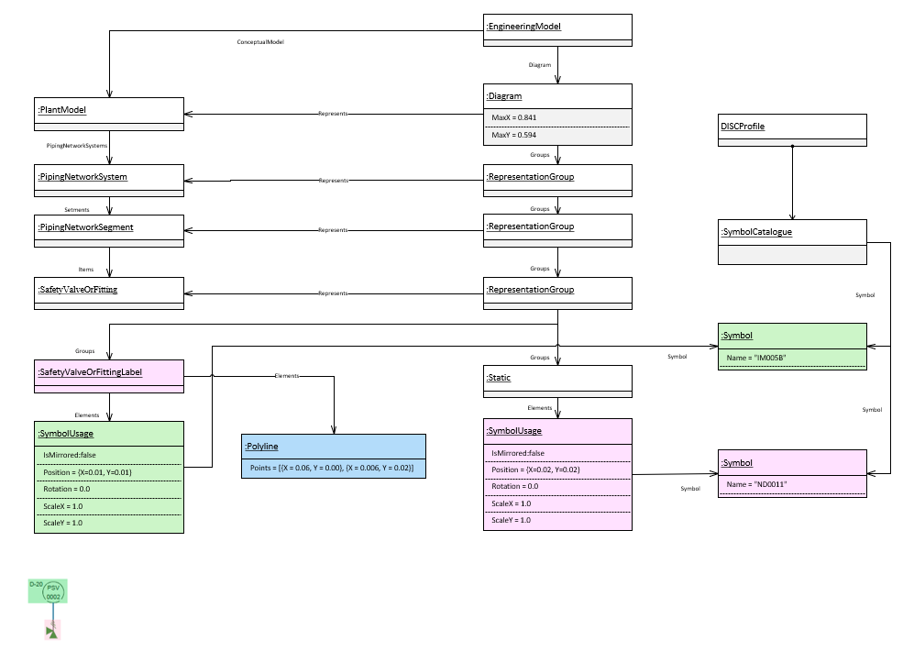
Figure 4: DEXPI model example Safety Valve Label Symbol Reference

Persistent ID
- The following cases have been discussed and agreed upon for this revision:
Case | Persistent ID required?
• Plant Break Down Structure Items e.g. Plant, System, Area | • Yes
• Tagged Items (created within the Contractors system) | • Yes
• Tagged Items (bulk created and reserved within Equinor STID) | • Yes
• Untagged items that are part of the process and are graphically represented on the P&ID e.g. flange, nozzle, vessel internals | • Yes
• Untagged items that are NOT notes or part of the process and are graphically reqresented on the P&ID e.g. property breaks, flow direction, elevation, labels. | • No
• Untagged Items using commonly accepted rules to group: e.g. Loop | • Yes for the example given
• Untagged Items used to group based on internal rules (that are not common across systems) e.g. DEXPI PipingNetworkSegment | • Persistent ID for PipingNetworkSystem.
 | • No persistent ID for PipingNetworkSegment or Pipe (Centerline). Reassess after creating/applying update use cases.
• Items without graphical representation on the P&ID created ‘on the fly’ during export as required by DEXPI which contain process related information e.g. SignalConveyingFunction (used for alarms) | • Yes
• Items without graphical representation on the P&ID created ‘on the fly’ during export as required by DEXPI which contain NO process related information e.g. VirtualPipingConnector, ProcessSignalGeneratingFunction | • No reassess after update use cases.
• MeasuringLineFunction | • No not required
• Notes | • Yes

- Using the definitions from the cases above persistent ID requirements for the DEXPI class types are defined as follows:
DEXPI class type | Comment | Persistent ID
PlantStructureItem | All subtypes which are included in the export | Required
Note |  | Required
PipeOffPageConnector |  | Required
SignalOffPageConnector |  | Required
Equipment | All subtypes which have a representation on the P&ID | Required
Nozzle | NOT included: items without a RepresentationTypeGroup (Graphical representation) | Required
ProcessColumnComponent |  | Required
PipingNetworkSystem |  | Required
PipingComponent | All subtypes which have a representation on the P&ID.  NOT included: items without a RepresentationTypeGroup (Graphical representation) | Required
ControlledActuator |  | Required
ProcessInstrumentationFunction | And subtypes. | Required
InstrumentationLoopFunction |  | Required
SignalConveyingFunction | NOT included: MeasuringLineFunction | Required
PipingNetworkSegment |  | Not Required
PipingConnection |  | Not Required
MeasuringLineFunction |  | Not Required
ActuatingElectricalFunction |  | Not Required
ActuatingSystem |  | Not Required
ActuatingFunction |  | Not Required
ProcessSignalGeneratingFunction |  | Not Required
ProcessSignalGeneratingSystem |  | Not Required
TransmissionSystem |  | Not Required
SensingLocation |  | Not Required
PropertyBreak |  | Not Required
OperatedValveReference |  | Not Required
PipingNode |  | Not Required
Pipe |  | Not Required

File & Drawing Metadata
File and Drawing Metadata are the high-level data used to give information about the file itself and also drawing top level details. Many of the MetaData attribute are part of the drawing template as shown below:
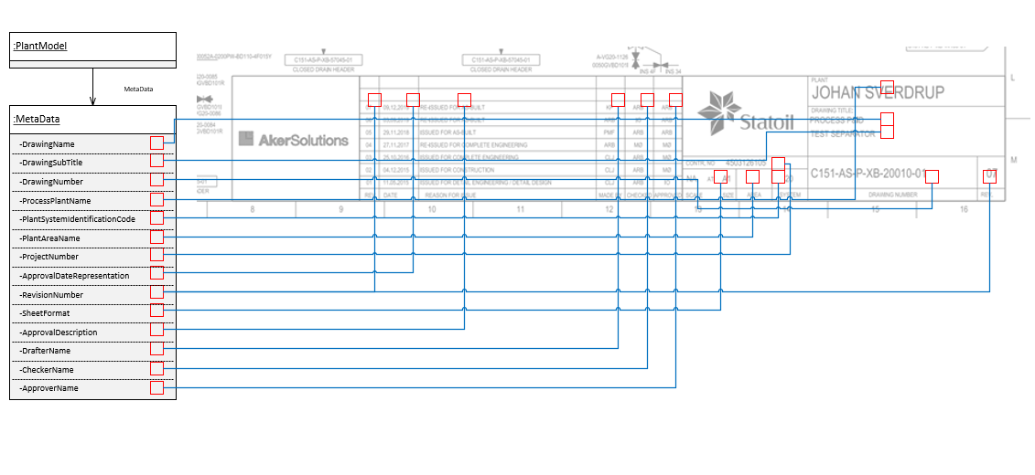
Figure 5: DEXPI MetaData model example

Requirement Details

DEXPI XML:
- Only current revision information shall be transferred in the export file.
- File encoding shall be ‘utf-8’
- Each DEXPI transfer file shall include the import references
Import prefix | Source
Core | https://data.dexpi.org/models/2.0.0/Core.xml
Plant | https://data.dexpi.org/models/2.0.0/Plant.xml
Profile | http://www.dexpi.org/specification/Temp/Profile
DiscProfile | Source to be defined can be set as: http://www.to.define
- Each DEXPI transfer file shall include the following EngineeringModel XML attributes
Attribute | Comment | Value
ExportDateTime | Date time of export | 2025-10-28T09:00:00
OriginatingSystemName | Name of originating system | pnb Toolbox Library
OriginatingSystemVendorName | Name of originating vendor | pnb plants &amp; bytes GmbH, Aachen, Germany
OriginatingSystemVersion | Version of the originating system | current

Drawing Metadata:
- Each DEXPI transfer file shall include the following attributes as part of the drawing metadata element:

Attribute | RDS | Value Example | Comment
ApprovalDateRepresentation | http://sandbox.dexpi.org/rdl/ApprovalDateRepresentationAssignmentClass
ApprovalDescription | http://sandbox.dexpi.org/rdl/ApprovalDescriptionAssignmentClass
ApproverName | http://sandbox.dexpi.org/rdl/ApproverNameAssignmentClass
CheckerName | http://sandbox.dexpi.org/rdl/CheckerNameAssignmentClass
DrafterName | http://sandbox.dexpi.org/rdl/DrafterNameAssignmentClass |  | P&ID drafter user ID
DrawingName | http://data.posccaesar.org/rdl/RDS2102503531 | PIPING AND INSTRUMENT DIAGRAM
DrawingNumber | http://sandbox.dexpi.org/rdl/DrawingNumberAssignmentClass | PID.001
DrawingSubTitle | http://sandbox.dexpi.org/rdl/DrawingSubTitleAssignmentClass | TEST P&ID
PlantAreaName | http://sandbox.dexpi.org/rdl/AreaIsa95NameAssignmentClass
PlantSystemIdentificationCode | http://sandbox.dexpi.org/rdl/PlantSystemIdentificationCodeAssignmentClass | 20
ProcessPlantIdentificationCode | http://sandbox.dexpi.org/rdl/ProcessPlantIdentificationCodeAssignmentClass | D
ProcessPlantName | http://sandbox.dexpi.org/rdl/ProcessPlantNameAssignmentClass | KRAFLA
ProjectNumber | http://sandbox.dexpi.org/rdl/ProjectNumberAssignmentClass
RevisionNumber | http://sandbox.dexpi.org/rdl/RevisionNumberAssignmentClass | 01
SheetFormat | http://sandbox.dexpi.org/rdl/SheetFormatAssignmentClass | NTS at A1
CreatorName | http://sandbox.dexpi.org/rdl/CreatorNameAssignmentClass |  | User ID of person exporting P&ID to DEXPI

Process Plant, Plant System & Plant Area
System numbering codes and plant area codes are both given on the P&ID to provide information about the engineering elements. DEXPI provides for the transfer of these elements via the PlantSystem & PlantArea class definitions.

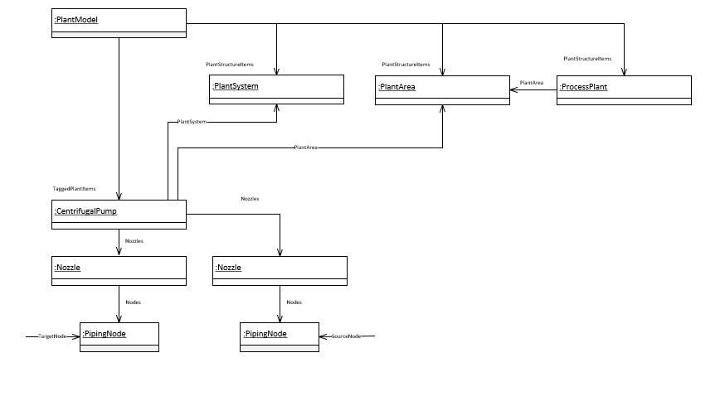
Figure 6: DEXPI ProcesPlant, PlantSystem & PlantArea model example

Requirement Details:
- ProcessPlant class shall be transferred.
- Each ProcessPlant DEXPI transfer object shall include the following attributes:
Attribute | RDS | Value Example | Comment
ProcessPlantIdentificationCode | http://sandbox.dexpi.org/rdl/ProcessPlantIdentificationCodeAssignmentClass | D | Plant code
- PlantSystem association shall be used where this information is available for an item.
- Each PlantSystem DEXPI transfer object shall include the following attributes:
Attribute | RDS | Value Example | Comment
PlantSystemIdentificationCode | http://sandbox.dexpi.org/rdl/PlantSystemIdentificationCodeAssignmentClass | 20 | System code associated with the item

- PlantArea association shall be used where this information is available for an item.
- Each PlantArea DEXPI transfer object shall include the following attributes:
Attribute | RDS | Value Example | Comment
PlantAreaIdentificationCode | http://sandbox.dexpi.org/rdl/PlantAreaIdentificationCodeAssignmentClass | B23 | Area code associated with the item

Equipment

Main Equipment
Equipment is the main items shown in a P&ID to perform the process required treatment. The plant equipment is shown in the P&ID by an icon showing the equipment in basic manner. Equipment is usually identified by a name and unique tag (Unique identifier that is assigned to a field device, skid or equipment).
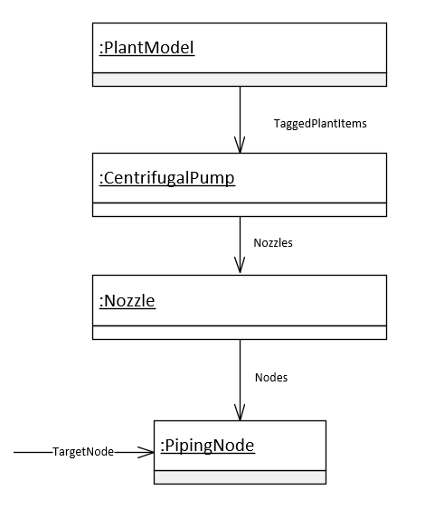
Figure 7: DEXPI Equipment model example

Requirement Details:
- Each Equipment DEXPI transfer object shall include the following attributes when available:

Attribute | RDS | Value Example | Comment
ObjectDisplayName | http://noaka.org/rdl/ObjectDisplayNameAssignmentClass | D-20PA001 | Label text as displayed on the P&ID
Sequence | http://noaka.org/rdl/SequenceAssignmentClass | 001 | Sequence number which is part of the tag name.
TagType | http://noaka.org/rdl/TagTypeAssignmentClass | PA | Letter code indicating the function of the item.
EquipmentDescription | http://data.posccaesar.org/rdl/RDS2181987301 | GEAR PUMP | Functional service description of the tagged item.
TagName | http://sandbox.dexpi.org/rdl/TagNameAssignmentClass | D-20PA001 | Tag name as stored in the tag register system.
Elevation | http://noaka.org/rdl/ElevationAssignmentClass | EL. 400000 | Elevation information for the equipment.

- For each Equipment DEXPI transfer object represented by a symbol with a type code text component shall include the following attribute:
Attribute | RDS | Value Example | Comment
TypeCode | http://noaka.org/rdl/TypeCodeAssignmentClass | E | Text code to be displayed within the symbol. Ref: [5] ‘Label Attributes’

Connnected Equipment
Main equipment such as pumps are sometimes drafted with a connected driver on the P&ID. It is important to be able to capture this relationship for design and maintenance. Within DEXPI 1.4 this relationship is captured using the TransmissionSystem conceptual data model.
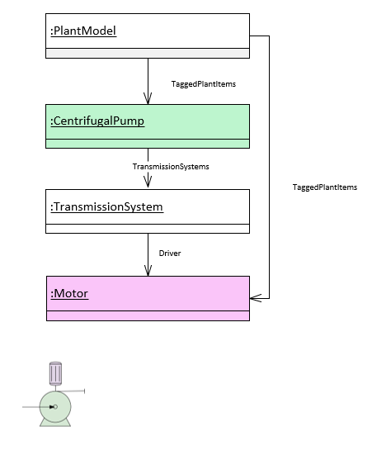
Figure 8: DEXPI Connected Equipment model example

Requirement Details:
- Direct connections between a driver type equipment and a driven type equipment e.g. motor and pump or motor and compressor shall use the TransmissionSystem conceptual modelling approach as shown above.

Custom Equipment Package
Package boundaries are often drafted as part of the P&ID and are a placeholder/link to a self-contained process system, functional unit or separate drawing. Packages have historically been drafted to include a simplified version of the elements it encapsulates, however, going forward this will be replaced by a simple linking identifier e.g. hyperlink for main equipment tag.
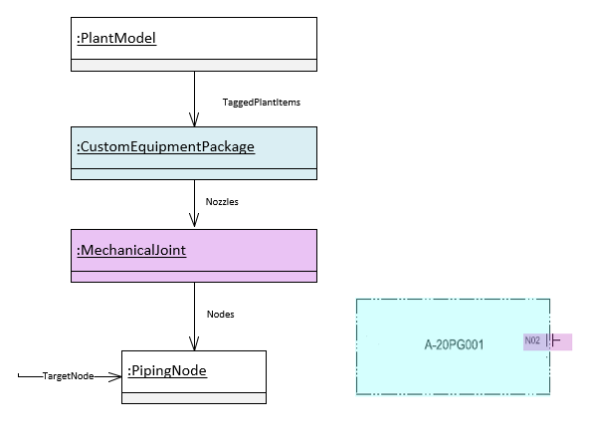
Figure 9: DEXPI Custom Equipment Package model example

Requirement Details:
- Each CustomEquipmentPackage DEXPI transfer object shall include the following attributes:
Attribute | RDS | Value Example | Comment
ObjectDisplayName | http://noaka.org/rdl/ObjectDisplayNameAssignmentClass | A-20PG001 | Label text as displayed on the P&ID
- Each MechanicalJoint DEXPI transfer object shall include the following attributes where available:
Attribute | RDS | Value Example | Comment
ObjectDisplayName | http://noaka.org/rdl/ObjectDisplayNameAssignmentClass | A-20PG001 | Label text as displayed on the P&ID
JointConnectionSize | http://noaka.org/rdl/JointConnectionSizeAssignmentClass | DN 25 | Connection size that needs to be aligned for package

Equipment Internals
The term equipment internals in this instance refers to those internal elements that are drafted as part of the vessel/process column specifically for the DISC project these elements refer to those in Figure 10: Equipment Internals
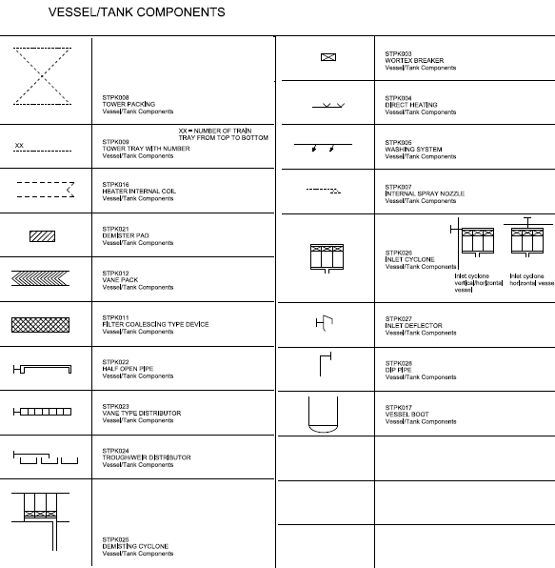
Figure 10: Equipment Internals
These elements shall be modelled using the ProcessVesselComponent class element or subtype. The ProcessVesselComponent class can be either a subcomponent of a Vessel or a ProcessColumn. Relevant subtypes are listed in the profile specification with the associated symbol and RDL references.
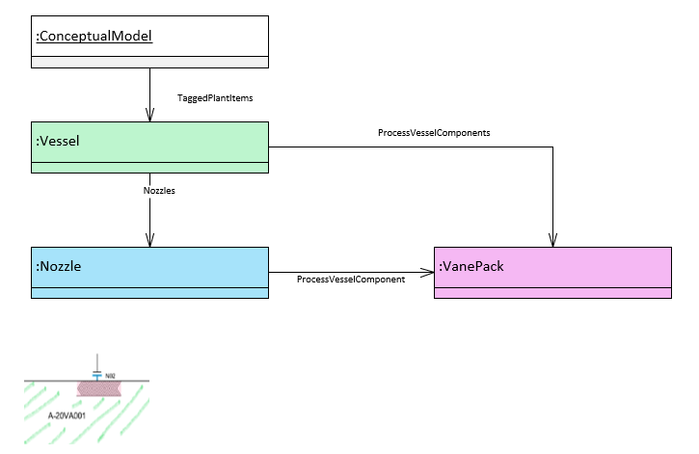
Figure 11: DEXPI Vessel/ProcessColumn internal model example

Requirement Details:
- Each ProcessVesselComponent or subtype DEXPI transfer object shall include the following attributes when available:

Attribute | RDS | Value Example | Comment
ComponentIdentifier | http://noaka.org/rdl/lComponentIdentifierAssignmentClass | 01 | Used especially for Tower Tray identification

Piping
A Piping System is an assembly of various components put together with a proper method of joints, functionally to transport fluid from its source to destination. The different components put together are defined as piping components. They are designed for withstanding the operating and design conditions specified in the process parameters. The following sub-sections detail specific subsets of requirements based on component group types within the piping system.
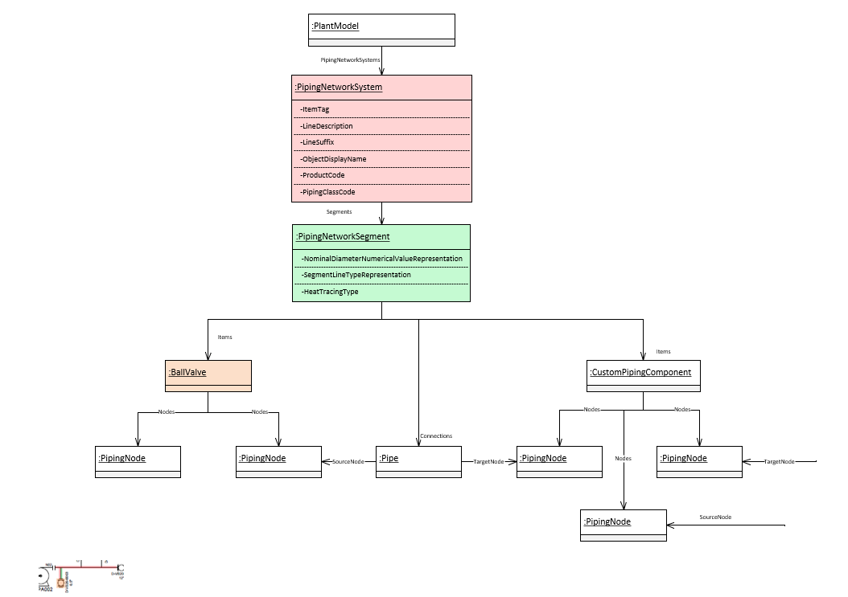
Figure 12: DEXPI PipingNetworkSystem model example

Piping
This sub-section details the transfer requirements related to the PipingNetworkSystem, PipingNetWorkSegment and Pipe elements.

Requirement Details:
- Each pipeline shall be represented by a separate PipingNetworkSystem
- PipingNetworkSystems shall contain all PipingNetworkSegments that share the same pipeline name ‘ItemTag’ attribute value.
- Each pipeline shall contain one or more PipingNetworkSegments where the topology of the PipingNetworkSegments is defined in ANNEX A: PipingNetworkSegment topology details
- Where heat tracing is utilized, this information shall be transferred via DEXPI using the HeatTracingType attribute on the PipingNetworkSegment. All elements within the PipingNetworkSegment shall inherit the heat tracing setting using one of the following values:
  - NULL: heat tracing system has not yet been evaluated
  - HeatTracingSystem: Heat tracing will be used on the piping network system
  - NoHeatTracingSystem: Heat tracing will not be used on the piping network system
- Each PipingNetworkSystem DEXPI transfer object shall include the following attributes:
Attribute | RDS | Value Example | Comment
ItemTag | http://noaka.org/rdl/ItemTagAssignmentClass | D-20L00001A | The pipeline tag number.
LineDescription | http://noaka.org/rdl/LineDescriptionAssignmentClass | D-20L00001A-1800PL-AD200- | Complete Line number as indicated on the P&ID.
LineSuffix | http://noaka.org/rdl/LineSuffixAssignmentClass | A | Size indicator suffix
ObjectDisplayName | http://noaka.org/rdl/ObjectDisplayNameAssignmentClass | D-20L00001A-1800PL-AD200- | Label text as displayed on the P&ID
ProductCode | http://noaka.org/rdl/ProductCodeAssignmentClass | PL | Product service code for the line
PipingClassCode | http://sandbox.dexpi.org/rdl/PipingClassCodeAssignmentClass | AD750 | Piping class for the line
HeatTracingRequirement | http://noaka.org/rdl/HeatTraceRequiredAssignmentClass | Y/N/S | Is heat tracing required for some/all of the pipeline: Y-Yes; N-No; S-Safety critical
- Each PipingNetworkSegment DEXPI transfer object shall include the following attributes:
Attribute | RDS | Value Example | Comment
ItemTag | http://noaka.org/rdl/ItemTagAssignmentClass | D-20L00001A | The pipeline tag number.
SegmentLineTypeRepresentation | http://noaka.org/rdl/ SegmentLineTypeRepresentationAssignmentClass | Primary/Secondary/Utility | Indicate line type to use
HeatTracingType | http://sandbox.dexpi.org/rdl/HeatTracingTypeSpecialization | NoHeatTracingSystem | Indicates that no heat tracing is used.
NominalDiameterNumericalValueRepresentation | http://sandbox.dexpi.org/rdl/ NominalDiameterNumericalValueRepresentationAssignmentClass | 800 | Nominal diameter for the line

Piping Components
Piping components are those components that are connected in-line with the pipe to support the transport of fluid from its source to destination. Piping components referred to in this section can be (but are not limited to) one of the following types:
- Pipe fittings
- Flanges
- Gaskets
- Manually Operated Valves
- Special Items
- Nozzles
- Reducers
The Piping Components group as discussed here does not include pipes, safety valves or actuated valves. Safety valves and actuated valves are detailed in Instrumentation section.

Requirement Details:
- NozzleTee symbol shall be used to represent all nozzles on the P&ID
- Where a nozzle has not been included on the drawing between the equipment and the pipe/measuring line the transfer shall include a ‘virtual’ nozzle to ensure compliance with DEXPI. A ‘virtual’ nozzle element will not have a graphical representation DEXPI RepresentationTypeGroup.
- BlindFlange DEXPI class mapping shall be used in the transfer file for the flange where there is one PipingNode connection
- Flange DEXPI class mapping shall be used in the transfer file for the flange where there are two PipingNode connections.
- PipeTee class shall be used to provide for direct pipe to pipe tee connections i.e., where there is no graphical representation of a connecting piping compontent between the two pipes forming a ‘T’ type junction shown on the P&ID. A ‘virtual’ PipeTee element will not have a graphical representation DEXPI RepresentationTypeGroup

- Each PipingComponent DEXPI transfer object shall include the following attributes when available/applicable:

Attribute | RDS | Value Example | Comment
ItemTag | http://noaka.org/rdl/ItemTagAssignmentClass | D-VB20-0002 | Tag name as stored in the tag register
ObjectDisplayName | http://noaka.org/rdl/ObjectDisplayNameAssignmentClass | D-VB20-0002 | Label text as displayed on the P&ID
Sequence | http://noaka.org/rdl/SequenceAssignmentClass | 0002 | Sequence number which is part of the tag number.
TagType | http://noaka.org/rdl/TagTypeAssignmentClass | VB | Letter code indicating the function of the item.

- For each PipingComponent DEXPI transfer object that is of type OperatedValve (or sub-type) shall include the following attributes in addition to the attributes defined in the table above when available. In the main these attributes will be used within the label for the Valve (Ref: ANNEX D: Valve Label Details)

Attribute | RDS | Value Example | Comment
ValvePosition | http://noaka.org/rdl/ValvePositionAssignmentClass | NC | Valve Normal Position: Used to define how the graphics for the valve shall be displayed (e.g. black/closed or white/open)  Symbol options provided in the symbol library show how this will be represented. Ref [7]
VDS | http://noaka.org/rdl/VDSAssignmentClass | BMBD101R | Valve Data Sheet
NominalDiameter | http://noaka.org/rdl/NominalDiameterAssignmentClass | 0200 | Nominal diameter of the valve
TrimType | http://noaka.org/rdl/TrimTypeAssignmentClass | FB | Trim Type: e.g. Full Bore / Reduced Bore
LockMechanism | http://noaka.org/rdl/LockMechanismAssignmentClass | CSO | Lock Mechanism code
BarrierInformationFlowIn | http://noaka.org/rdl/BarrierInformationFlowInAssignmentClass | DP | Barrier Information e.g. DP (double piston) for the flow in side of the valve
BarrierInformationFlowOut | http://noaka.org/rdl/BarrierInformationFlowOutAssignmentClass | SR | Barrier Information e.g. SR (Self Relief) for the flow out side of the valve
TypicalReference | http://sandbox.dexpi.org/rdl/TypicalReferenceAssignmentClass |  | Code identifying the associated Typical if part of an actuated system.
- Each Nozzle DEXPI transfer object shall include the following attributes when available/applicable:

Attribute | RDS | Value Example | Comment
IsVirtualMount | http://noaka.org/rdl/IsVirtualMountAssignmentClass | FALSE | Set to ‘TRUE’ if the Nozzle is included is representing an external mounting on the equipment.
ItemTag | http://noaka.org/rdl/ItemTagAssignmentClass | M01 | Tag name as stored in the tag register
ObjectDisplayName | http://noaka.org/rdl/ObjectDisplayNameAssignmentClass | M01 | Label text as displayed on the P&ID
Sequence | http://noaka.org/rdl/SequenceAssignmentClass | 01 | Sequence number which is part of the tag number.
TagType | http://noaka.org/rdl/TagTypeAssignmentClass | M | Letter code indicating the function of the item.
- For each PipingComponent DEXPI transfer object that is defined as a special item shall include the following attribute:

Attribute | RDS | Value Example | Comment
SpecialItemNumber | http://noaka.org/rdl/SpecialItemNumberAssignmentClass | 3029 | Text for special item identification to be shown in SpecialItem label.
- For each PipeReducer DEXPI transfer object shall include the following attributes when available/applicable:

Attribute | RDS | Value Example | Comment
NominalDiameterIn | http://noaka.org/rdl/NominalDiameterInAssignmentClass | 0100 | Nominal diameter into the reducer
NominalDiameterOut | http://noaka.org/rdl/NominalDiameterOutAssignmentClass | 0200 | Nominal diameter out of the reducer

Instrumentation
Instrumentation is the items shown in a P&ID required to run, monitor and control a specific process. E.g. Indicators, Recorders, Controllers , including: pressure, temperature and flow instruments, control valves, pressure safety valves, meters etc.

Instrumentation (Off-Line Instrumentation)
Example Ref:
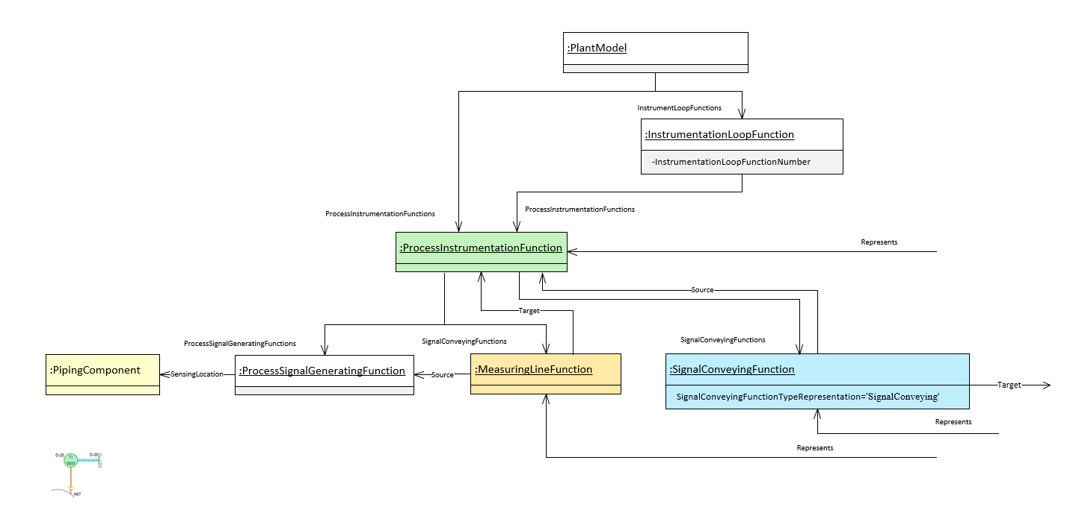
Figure 13:DEXPI Instrumentation model example within connection to PipingComponent (Flange)

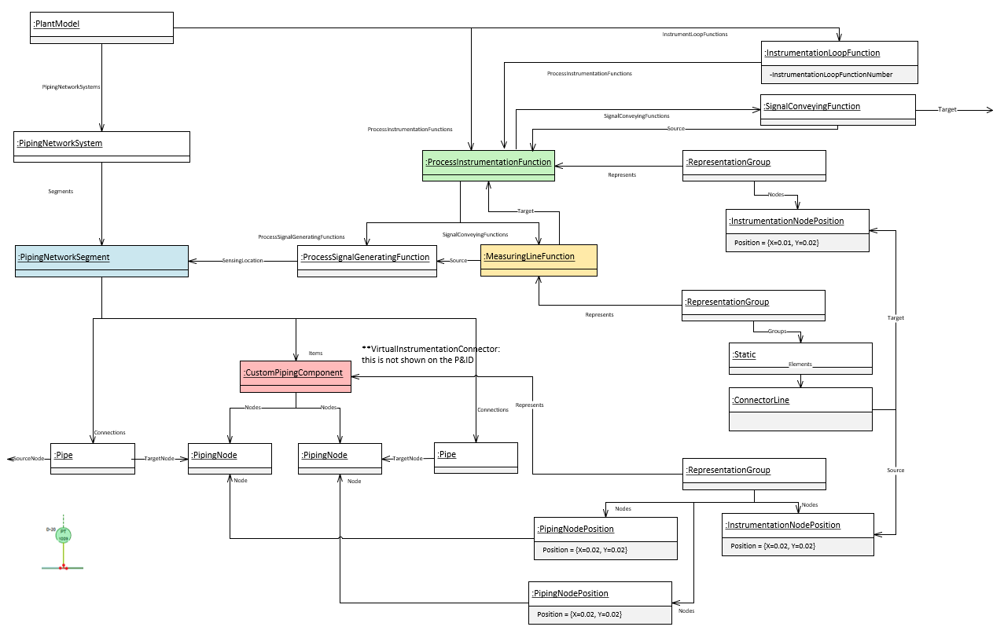
Figure 14:DEXPI Instrumentation model example within connection to PipingNetworkSegment and graphical connection nodes

Requirement Details:
- All instruments (not incl. actuated and safety valves) shall be represented by a ProcessInstrumentFunction class element or class subtype (dependant on project specific rules for typing) PIF in DEXPI.
- InstrumentationLoopFunction class must be used as a 'grouping' mechanism for ProcessInstrumentFunction (PIF) elements where the loop identifier for those PIF items is known.
- InstrumentationLoopFunction class shall only be created in the export if there is an associated ProcessInstrumentationFunction class.
- Signal conveying lines shall be represented using DEXPI SignalConveyingFunction class using the SignalConveyingFunctionTypeRepresentation to define the line style Ref: [5] for valid type values.
- SignalConveyingFunction Parent shall be the ProcessInstrumentationFunction item associated with the ‘sending’ PIF. *Ensures consistency with cases where the PIF is associated with an ActuatingFunction.
- Measure lines between instrument and piping component shall be represented using MeasuringLineFunction class.
- DEXPI MeasuringLineFunction shall have an ProcessSignalGeneratingFunction as its Source
- DEXPI ProcessInstrumentationFunction reference shall contain a ProcessInstrumentationFunctionType descriptor attribute where both a field device and shared display/shared control element exists for the object and the tag name for these objects is the same.
- The DEXPI SensingLocation for the DEXPI ProcessSignalGeneratingFunction shall be either Nozzle, PipingComponent or PipingNetworkSegment as per the DEXPI standard. In the case where an off-line instrument is drawn with a connection direct to a pipe the SensingLocation shall be set to PipingNetworkSegment.
- Each InstrumentationLoopFunction DEXPI transfer object shall include the following attributes when available:
Attribute | RDS | Value Example | Comment
InstrumentationLoopFunctionNumber | http://sandbox.dexpi.org/rdl/InstrumentationLoopFunctionNumberAssignmentClass | T0003 | Loop number use to group associated instruments.

- Each Instrument (PIF) shall include the following attributes when available:
Attribute | RDS | Value Example | Comment
ItemTag | http://noaka.org/rdl/ItemTagAssignmentClass | D-20TI-0003 | Tag name as stored in the tag register system.
ProcessInstrumentationFunctionLocation | http://noaka.org/rdl/ ProcessInstrumentationFunctionLocationAssignmentClass | Field / Primary / Auxiliary / Inaccessable | Location information for the instrument. Ref: Figure 15 for details regarding use of attribute for instrument symbols.
ProcessInstrumentationFunctionType | http://noaka.org/rdl/ ProcessInstrumentationFunctionTypeAssignmentClass | Discrete / SharedDisplaySharedControl | Differentiate between field device and control function block. Ref: Figure 15 for details regarding use of attribute for instrument symbols.
TagSuffix | http://noaka.org/rdl/TagSuffixAssignmentClass | A | Suffix code
ProcessInstrumentationFunctionCategory | http://sandbox.dexpi.org/rdl/ ProcessInstrumentationFunctionCategoryAssignmentClass | T | Function category
ProcessInstrumentationFunctionNumber | http://sandbox.dexpi.org/rdl/ ProcessInstrumentationFunctionNumberAssignmentClass | 0003 | Sequence number
ProcessInstrumentationFunctions | http://sandbox.dexpi.org/rdl/ ProcessInstrumentationFunctionsAssignmentClass | I | Additional functions
SetPointTemperature | http://noaka.org/rdl/SetPointTemperatureAssignmentClass | 100.0 DegreeCelsius | Temperature SetPoint value and UoM
SetPointGaugePressure | http://noaka.org/rdl/SetPointGaugePressureAssignmentClass | 17.0 Bar | Gauge Pressure SetPoint value and UoM
SetPointLength | http://noaka.org/rdl/SetPointLengthAssignmentClass | 20.0 Centimetre | Length SetPoint value and UoM
** The engineering naming system can sometimes allow for two instrument symbols (elements) to be given the same tag name even though they represent different functions. It is therefore key to include the above attributes, particularly the ProcessInstrumentationFunctionType attribute.

- For each ProcessInsrumentationFunction DEXPI transfer object represented by a symbol with an type code text component shall include the following attribute:
Attribute | RDS | Value Example | Comment
TypeCode | http://noaka.org/rdl/TypeCodeAssignmentClass | PSD | Text code to be displayed within the symbol. Ref: [5] ‘Label Attributes’ and Ref: Figure 15 for details regarding use of attribute for instrument symbols.

- Each SignalConveyingFunction DEXPI transfer object shall include the following attributes when available:
Attribute | RDS | Value Example | Comment
SignalConveyingFunctionTypeRepresentation | http://noaka.org/rdl/SignalConveyingFunctionTypeRepresentationAssignmentClass | SignalConveying | Linestyle type representation as defined in the Symbols legend for ‘SignalAndLineStyles’

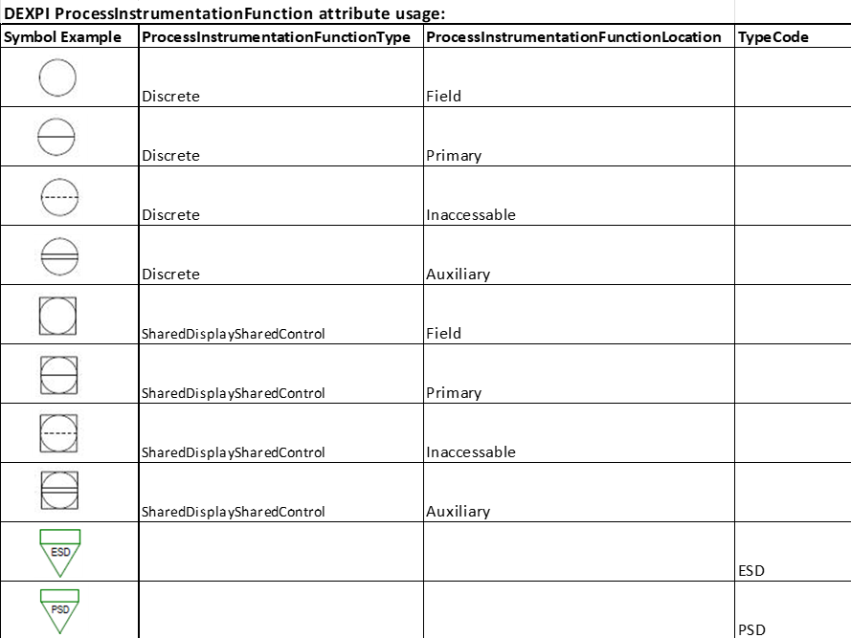

Figure 15: Instrumentation symbols with reference to ProcessInstrumentationFunctionType, ProcessInstrumentationFunctionLocation & TypeCode

Instrumentation (Off-Line instrument alarm and shut-down ‘cause’)
The following section details additional modelling and transfer requirements for instrument control functions that have alarm points and/or associated shutdown function(s).
Example Ref:
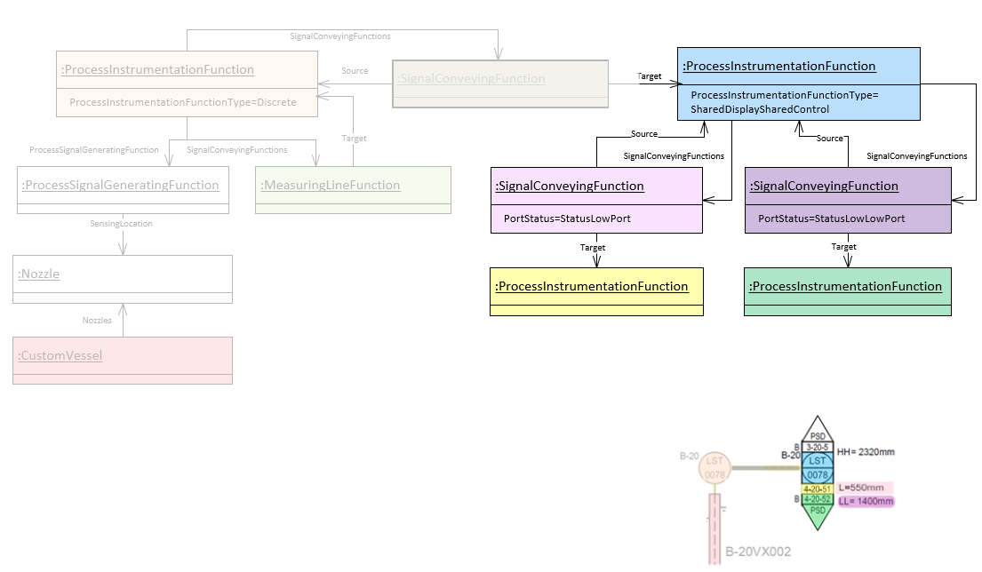
Figure 16: DEXPI Instrumentation Alarm & Shut-down ‘cause’ model

Requirement Details:
- Main requirement details are as per Ref: Instrumentation (Off-Line Instrumentation)
- Alarm levels shall be represented by DEXPI SignalConveyingFunction class type and shall include the following attributes:

Attribute | RDS | Value Example | Comment
PortStatus | http://sandbox.dexpi.org/rdl/PortStatusSpecialization | StatusLowLowPort | Alarm type

Instrumentation (Off-line Instrument shut-down ‘effect’ with multiple signal lines)
The following section details additional modelling and transfer requirements for instrument shutdown function(s) ‘effect’ elements.
Note: each shutdown ‘cause’ object may have one or more ‘effect’ objects.
Example Ref:
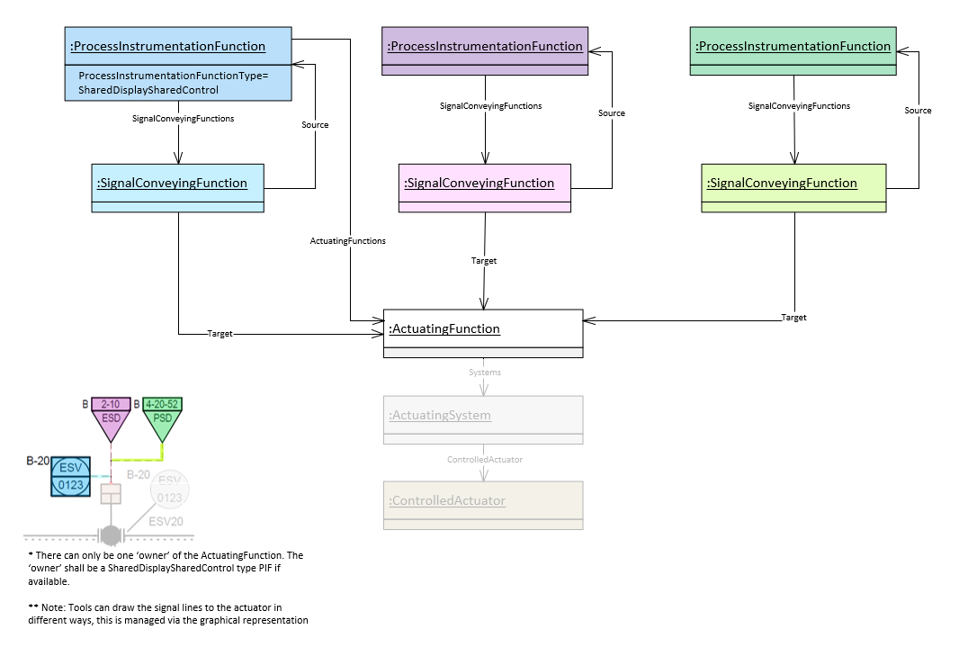
Figure 17: DEXPI Instrumentation Shut-down ‘effect’ model with multiple signal lines

Requirement Details:
- Main requirement details are as per Ref: Instrumentation (Off-Line Instrumentation)
- Where more than one signal is connected to an actuator the export system shall ensure that there is 1 ‘owner’ of the ActuatingFunction and that this shall be a SharedDisplaySharedControl type PIF if available.

Instrumentation Electrical Powered Equipment
This is a special grouping for electrical powered objects that receive/send signals from other electrical powered objects, controllers, shutdowns and equipment.
Example Ref:
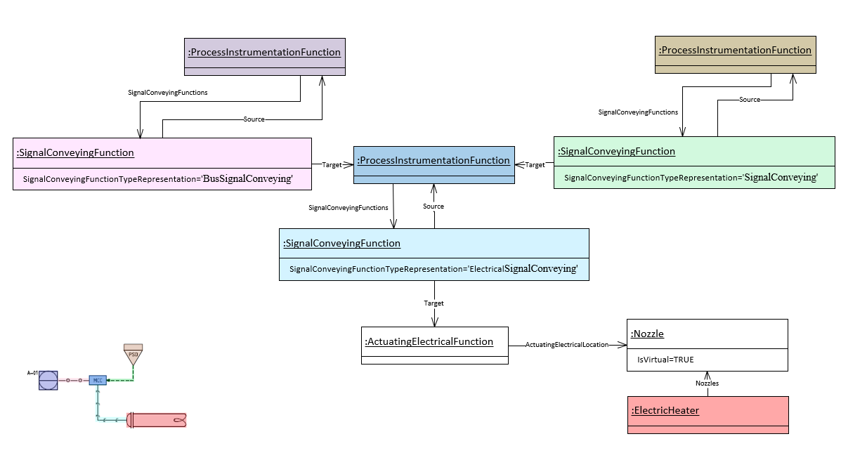
Figure 18: DEXPI Instrumentation Electrical Powered Equpment model

Requirement Details:
- Main requirement details are as per Ref: Instrumentation (Off-Line Instrumentation)
- Electrical signal lines between ‘instrument electrical powered equipment’ object and equipment shall be represented using SignalConveyingFunction class which has a DEXPI ActuatingElectricalFunction class as its Target.

Instrumentation (In-Line Instrumentation)
**Does not include instrument safety valves or actuated valves.
In-line instrumentation are those elements that are part of the piping network and provide an instrumentation function.
Example Ref:
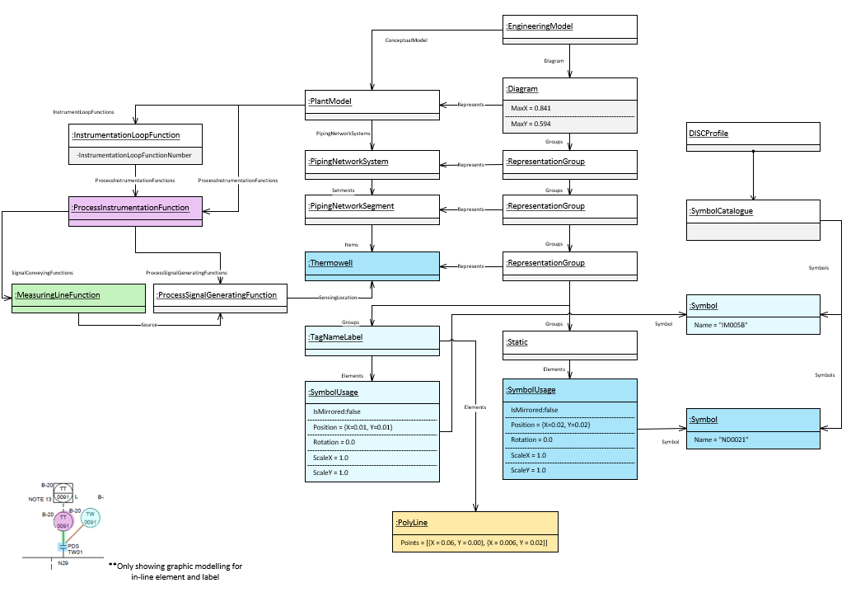
Figure 19: Example In-line thermowell with associated transmitter.

Requirement Details:
- All sensor well elements e.g. Thermowell shall be represented by a Sensorwell class element (or subtype) in DEXPI.
- All in-line instruments (not incl. actuated and safety valves) shall be represented by an InlineMeasuringElement (or subtype) class element in DEXPI.
- Measure lines between sensorwell or in-line instrument and off-line instrument shall be represented using MeasuringLineFunction class.
- DEXPI MeasuringLineFunction shall have an ProcessSignalGeneratingFunction as its Source

- Each DEXPI Sensorwell or InlineMeasuringElement (or subtype) shall include the following attributes when available:
Attribute | RDS | Value Example | Comment
InlinePrimaryElementFunctionCategory | http://noaka.org/rdl/InlinePrimaryElementFunctionCategoryAssignmentClass | T | Function category
InlinePrimaryElementFunctions | http://noaka.org/rdl/InlinePrimaryElementFunctionsAssignmentClass | W | Additional functions
ItemTag | http://noaka.org/rdl/ItemTagAssignmentClass | D-20TI-0003 | Tag name as stored in the tag register system.
TagType | http://noaka.org/rdl/TagTypeAssignmentClass | TI | Letter code indicating the function of the item.
InstrumentLoopNumber | http://noaka.org/rdl/InstrumentLoopNumberAssignmentClass | T0003 | Loop number use to group associated instruments.

- For each InlineMeasuringElement DEXPI transfer object that is defined as a special item shall include the following attribute:
Attribute | RDS | Value Example | Comment
SpecialItemNumber | http://noaka.org/rdl/SpecialItemNumberAssignmentClass | 5068 | Text for special item identification to be shown in SpecialItem label.

Instrumentation (Equipment-mounted)
The following section specifies additional modelling and DEXPI transfer requirements for equipment-mounted measuring instruments used for non-invasive measurement devices.
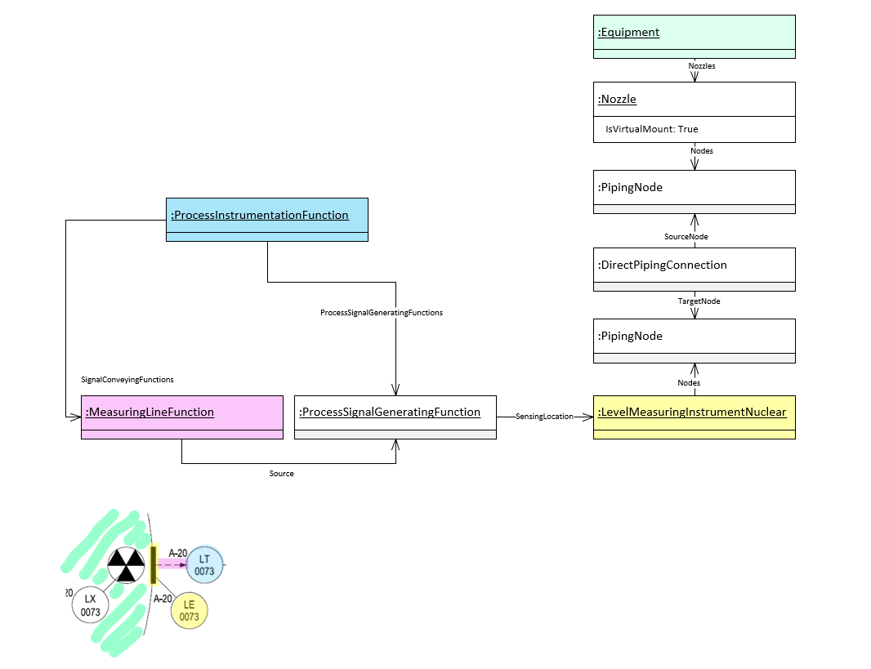
Figure 20: DEXPI Instrumentation (Equipment-mounted) model

Requirement Details:
- Main requirement details are as per Ref: Instrumentation (Off-Line Instrumentation)
- InlineMeasuringElement details are as per Ref: Instrumentation (In-Line Instrumentation)

Instrumentation (Safety and Self Acting Valves)
Instrumentation (Safety and Self-Acting Valves) shall be transferred as a DEXPI PipingComponent suptype within the DEXPI PipingNetworkSystem.
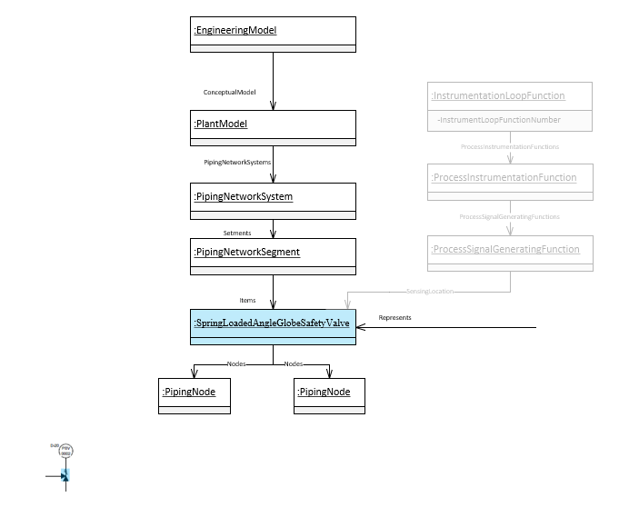
Figure 21: Instrumentation (Safety Valve) DEXPI model example

Requirement Details:
- Label symbol reference shall be transferred as a separate reference on the label element.
- Each DEXPI SafetyValveOrFitting (or subtype) shall include the following attributes when available:
Attribute | RDS | Value Example | Comment
ItemTag | http://noaka.org/rdl/ItemTagAssignmentClass | D-20PSV-0002 | Tag name as stored in the tag register system.
Sequence | http://noaka.org/rdl/SequenceAssignmentClass | 0002 | Sequence number which is part of the tag number.
TagType | http://noaka.org/rdl/TagTypeAssignmentClass | PSV | Letter code indicating the function of the item.
InstrumentLoopNumber | http://noaka.org/rdl/InstrumentLoopNumberAssignmentClass | P0002 | Loop number use to group associated instruments.
SetPointTemperature | http://noaka.org/rdl/SetPointTemperatureAssignmentClass | 100.0 DegreeCelsius | Temperature SetPoint value and UoM
SetPointGaugePressure | http://noaka.org/rdl/SetPointGaugePressureAssignmentClass | 17.0 Bar | Gauge Pressure SetPoint value and UoM
SetPointLength | http://noaka.org/rdl/SetPointLengthAssignmentClass | 20.0 Centimetre | Length SetPoint value and UoM

Instrumentation (Actuated Valves)
Actuated Valves are complex DEXPI structures as the valve is part of the piping package while instrumentation provides the automation. The special DEXPI modelling is shown below. Note that for actuated valves there are a number of RepresentationGroups required: including the representation for the valve, the actuator and the instrument bubble symbol.
Example Ref:
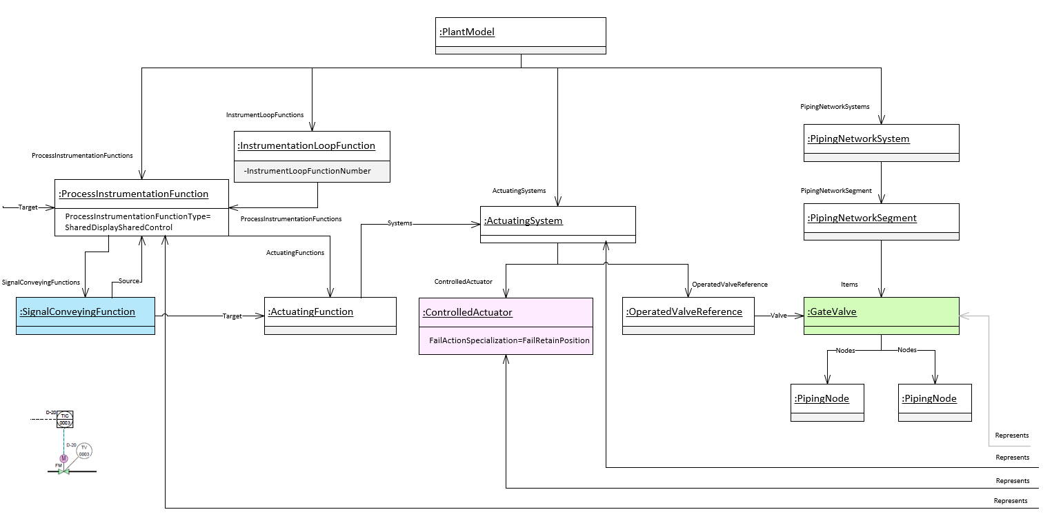
Figure 22: DEXPI Actuated Valve model example

Requirement Details:
- InstrumentationLoopFunction class association for an actuated valve shall be via the associated ProcessInstrumentationFunction object Ref: Figure 22: DEXPI Actuated Valve model example.
- DEXPI ActuatingFunction shall have an associated SignalConveyingFunction. The ActuatingFunction shall be the Target of the SignalConveyingFunction.
- The OperatedValve (or subtype) class shall contain the information relevant for the tag.
- The OperatedValve (or subtype) class element shall ‘own’ the link to the label for this item type.
- For each Actuator (ControlledActuator) DEXPI transfer object represented by a symbol with an type code text component shall include the following attribute:
Attribute | RDS | Value Example | Comment
TypeCode | http://noaka.org/rdl/TypeCodeAssignmentClass | M | Text code to be displayed within the symbol. Ref: [5] ‘Label Attributes’
FailAction | http://sandbox.dexpi.org/rdl/FailActionSpecialization | FC | Fail Action code associated with the actuator.

Equipment Box
Equipment box shall not be transferred.
This section has been left as a reference in the event that the project determines it is necessary to transfer equipment box information.
Equipment Box/Table is the addition of a tabulated list of attribute name and value pairs that are associated with an equipment shown on the P&ID. The extent of the requirements for this list of attributes shall be as per the project requirements. The Equipment box transfer will be managed similarly to the symbol transfer via a reference ID.

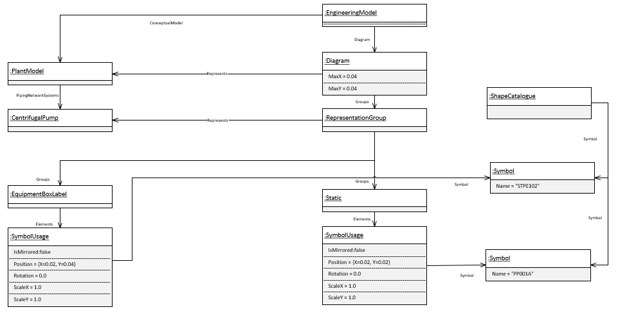
Figure 23: DEXPI Equipment box model example

Requirement Details:
- Any attributes that are shown in the equipment box shall be transferred with the associated item in the transfer file.
- During the project only Tag Name and Description are required to be transferred using the DEXPI attribute definitions below:

Attribute | RDS | Value Example | Comment
TagName | http://sandbox.dexpi.org/rdl/TagNameAssignmentClass | D-20PA001 | Tag name as stored in the tag register system.
EquipmentDescription | http://data.posccaesar.org/rdl/RDS2181987301 | GEAR PUMP | Functional service description of the tagged item.

Labels
DISC DEXPI requirements define that for most object symbols the label will form part of the overall graphical representation Ref: [5] ‘Label Attributes’. For other object types the information for that object may be displayed in an associated label symbol e.g. for Off-line Instruments. For this type of label, the DEXPI representation is provided: Ref: (Figure 4: DEXPI model example Safety Valve Label Symbol Reference) where the link between the object and the label is via the ComponentName attribute.
It is expected that the label(s) defined for each symbol shall be displayed in the location given by the symbol definition. However, this may not be feasible due to space constraints on the P&ID. In which case the label will be repositioned and this new position information along with the attribute association to the label text shall be provided in the transfer file as shown in the example below.
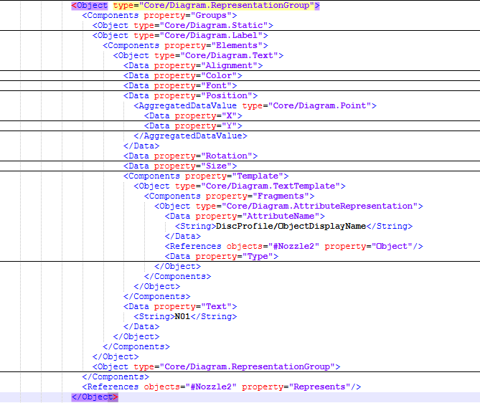
Figure 24: DEXPI 2.0 implementation for change of position of naming label

Note
Note is the text added to the P&ID to provide additional information about an item or items on the drawing. Each note shall be linked to at least one item on the drawing, however, the modelling described below will allow for notes that are not connected. An item on the drawing can have more than one note.
DEXPI standard does not currently contain a note class element, this has been identified as a gap within DEXPI. A suggestion has been provided to the DEXPI content group regarding the introduction of a new ‘Note’ class element as a direct child of the Conceptual Model, this suggestion has been approved for release in the next version of the DEXPI standard. It has also been approved for use within the DISC DEXPI project and adjustments to the DEXPI verificator will be made accordingly to ensure that this new class type does not produce verification errors.

Example Ref:

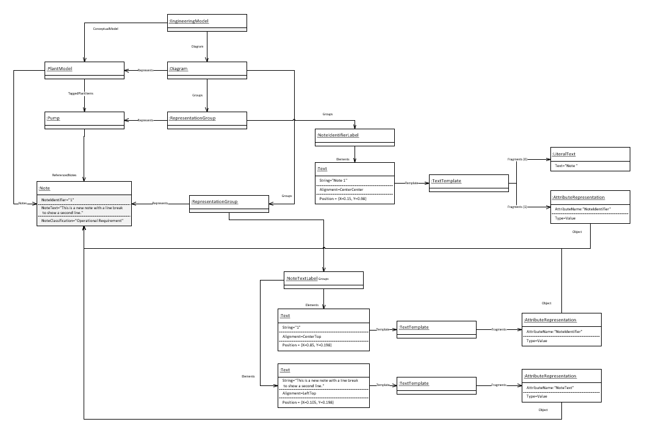
Figure 25: DISC DEXPI Notes model example
Requirement Details:
- Each note shall have a PersistentID
- For each Note DEXPI transfer object shall include the following attributes (which will be considered as Dexpi attributes and not custom attributes in this project):

Attribute | RDS | Value Example | Comment
NoteIdentifier | http://sandbox.dexpi.org/rdl/NoteIdentifierAssignmentClass | 1 | Note reference ID
NoteText | http://sandbox.dexpi.org/rdl/NoteTextAssignmentClass | This is a note text | Note text
NoteClassification | http://sandbox.dexpi.org/rdl/NoteClassificationAssignmentClass | Technical Requirement | Note classification

Miscellaneous Graphics

Graphics Items with Symbol Reference
The following section contains details for those miscellaneous elements that are modelled within DEXPI 2.0 standard and are defined with a symbol reference.

PropertyBreak
Property break graphic shall be used to represent the break of one or more attributes.
The type of break being represented by the property break graphic shall be identified by associating the relevant logical break type. The graphic shall display the ‘break’ attribute(s) from the pipeline on either side of the property break graphic.
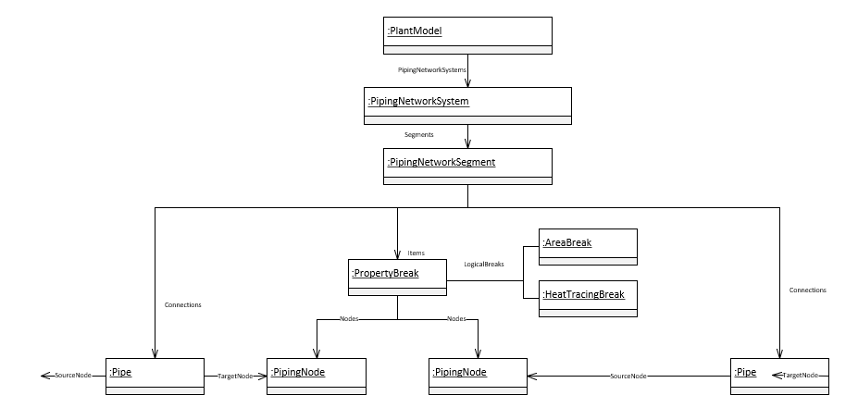
Figure 26: DEXPI PropertyBreak model example

Requirement Details:
- A PropertyBreak element is required to have the same x,y ordinate values for both process nodes as the PropertyBreak represents a single point.
- Each PropertyBeak DEXPI transfer object shall include the following attributes when available:
Attribute | RDS | Transfer Value | Value RDS
BreakIdentifier | http://noaka.org/rdl/BreakIdentifierAssignmentClass | Break identifier esp. TieIn | 156
BreakValue1 | http://noaka.org/rdl/BreakValue1AssignmentClass | Text for downstream break value(s) | A10  HT
BreakValue2 | http://noaka.org/rdl/BreakValue2AssignmentClass | Text for upstream break value(s) | A20  NO HT

- Each LogicalBreak DEXPI transfer object shall include the following attributes when available:
Attribute | RDS | Transfer Value | Value RDS
BreakValue1 | http://noaka.org/rdl/BreakValue1AssignmentClass | Text for downstream break value corresponding to break type | A10
BreakValue2 | http://noaka.org/rdl/BreakValue2AssignmentClass | Text for upstream break value corresponding to break type | A20

- Each TieInPoint logical break DEXPI transfer object shall include the following attributes when available:
Attribute | RDS | Transfer Value | Value RDS
CommissioningPackage | http://noaka.org/rdl/CommissioningPackageAssignmentClass | Commissioning package reference | CP1234
TieInPointIdentifier | http://noaka.org/rdl/TieInPointIdentifierAssignmentClass | TieInPointIdentifier | 156

Piping Off Page Connector (Out)
Piping Off Page Connector (OPC) graphic shall be used to represent a pipeline that continues elsewhere either on the same drawing or on another drawing with the flow direction ‘out’.
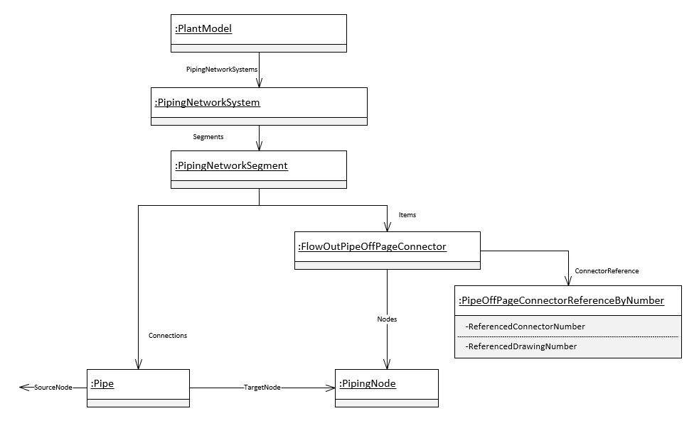
Figure 27: DEXPI FlowOutPipeOffPageConnector model example

Requirement Details:
- The piping off page connector (Flow Out) shall use the correct symbol to indicate flow direction ‘out’ to the side dependent on which side of the drawing the graphic is placed.
- Each FlowOutPipeOffPageConnector shall be transferred with an associated PipeOffPageConnectorReferenceByNumber DEXPI transfer object as per the figure above.
- Each PipeOffPageConnectorReferenceByNumber DEXPI transfer object shall include the following attributes when available:

Attribute | RDS | Value Example | Comment
ReferencedConnectorNumber | http://sandbox.dexpi.org/rdl/ReferencedConnectorNumberAssignmentClass | TBD | The unique key used to match this connector with its matching counterpart.
ReferencedDrawingNumber | http://sandbox.dexpi.org/rdl/ReferencedDrawingNumberAssignmentClass | TBD | The Name attribute of the Drawing that the matching ConnectorSymbol is on.
ReferencedDrawingDescriptor | http://noaka.org/rdl/ReferencedDrawingDescriptorAssignmentClass | CLOSED DRAIN | Typically the title of the referenced drawing.

Piping Off Page Connector (In)
Piping Off Page Connector (OPC) graphic shall be used to represent a pipeline that continues elsewhere either on the same drawing or on another drawing with the flow direction ‘in’.
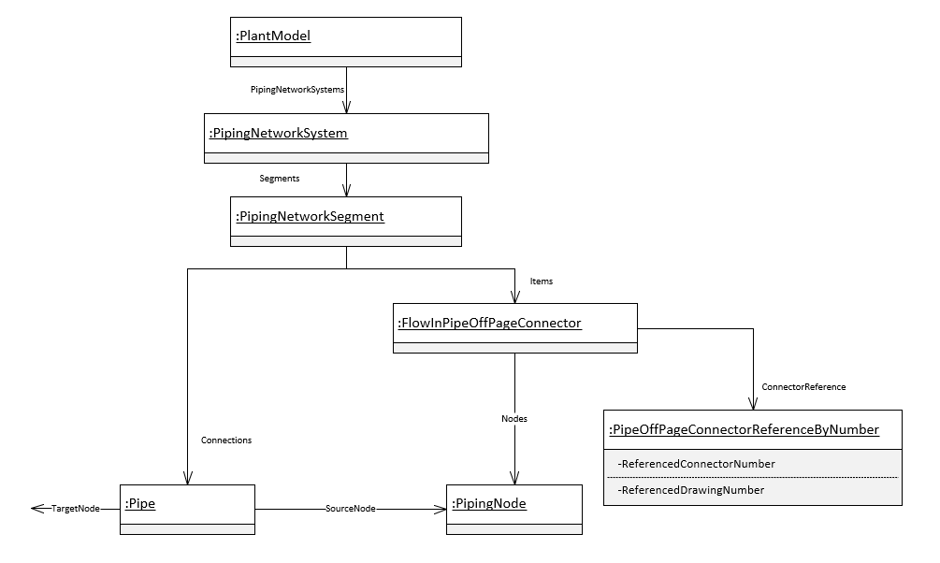
Figure 28: DEXPI FlowInPipeOffPageConnector model example

Requirement Details:
- The piping off page connector (Flow In) shall use the correct symbol to indicate flow direction ‘in’ from the side dependent on which side of the drawing the graphic is placed.
- Each FlowInPipeOffPageConnector shall be transferred with an associated PipeOffPageConnectorReferenceByNumber DEXPI transfer object as per the figure above.
- Each PipeOffPageConnectorReferenceByNumber DEXPI transfer object shall include the following attributes when available:

Attribute | RDS | Value Example | Comment
ReferencedConnectorNumber | http://sandbox.dexpi.org/rdl/ReferencedConnectorNumberAssignmentClass | TBD | The unique key used to match this connector with its matching counterpart.
ReferencedDrawingNumber | http://sandbox.dexpi.org/rdl/ReferencedDrawingNumberAssignmentClass | TBD | The Name attribute of the Drawing that the matching ConnectorSymbol is on.
ReferencedDrawingDescriptor | http://noaka.org/rdl/ReferencedDrawingDescriptorAssignmentClass | CLOSED DRAIN | Typically the title of the referenced drawing.

Piping Off Page Connector where flow is bi-directional or unknown
Where the flow is bi-directional or unknown the export tool shall manage the paired connectors for the pipe such that one connector is defined as ‘Flow Out’ and the other connector is defined as ‘Flow In’ as per the definitions above (Ref: Piping Off Page Connector (Out) and Piping Off Page Connector (In)). The symbol used to show the connector in this case is not related to flow direction.

Signal Off Page Connector (Out)
Signal Off Page Connector (OPC) graphic shall be used to represent a signal that continues elsewhere either on the same drawing or on another drawing with the flow direction ‘out’.
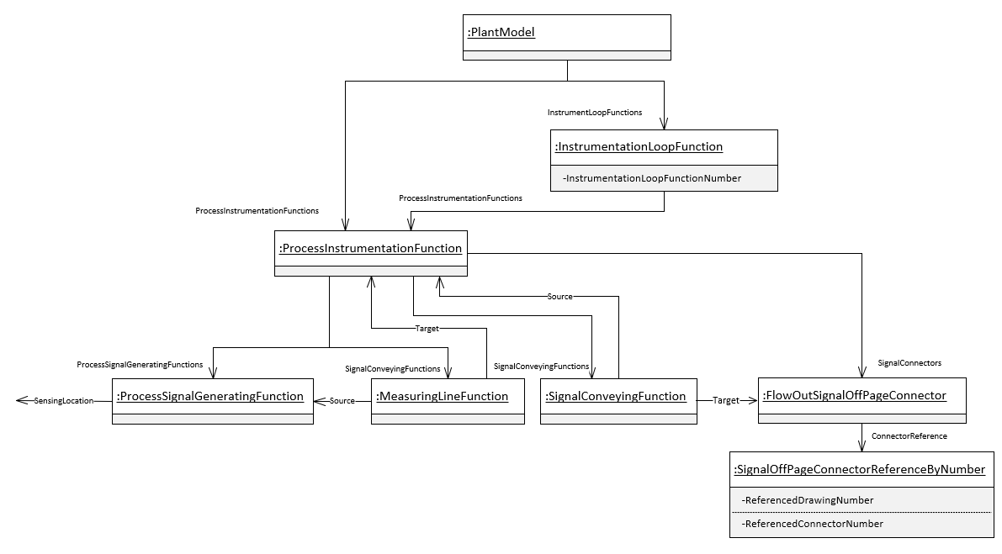
Figure 29: DEXPI FlowOutSignalOffPageConnector model example

Requirement Details:
- The signal off page connector (Flow Out) shall use the correct symbol to indicate flow direction out dependent on which side of the drawing the graphic is placed.
- Each FlowOutSignalOffPageConnector shall be transferred with an associated SignalOffPageConnectorReferenceByNumber DEXPI transfer object as per the figure above.
- Each SignalOffPageConnectorReferenceByNumber DEXPI transfer object shall include the following attributes when available:

Attribute | RDS | Value Example | Comment
ReferencedConnectorNumber | http://sandbox.dexpi.org/rdl/ReferencedConnectorNumberAssignmentClass | TBD | The unique key used to match this connector with its matching counterpart.
ReferencedDrawingNumber | http://sandbox.dexpi.org/rdl/ReferencedDrawingNumberAssignmentClass | TBD | The Name attribute of the Drawing that the matching ConnectorSymbol is on.
ReferencedDrawingDescriptor | http://noaka.org/rdl/ReferencedDrawingDescriptorAssignmentClass | CLOSED DRAIN | Typically the title of the referenced drawing.

Signal Off Page Connector (In)
Signal Off Page Connector (OPC) graphic shall be used to represent a signal that continues elsewhere either on the same drawing or on another drawing with the flow direction ‘in’.
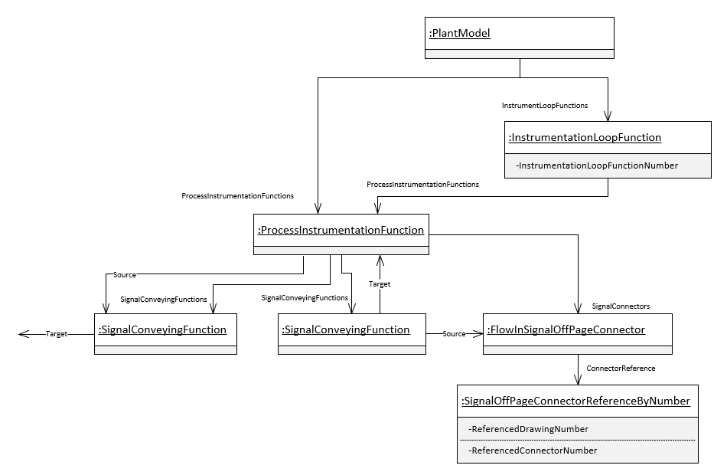
Figure 30: DEXPI FlowInSignalOffPageConnector model example

Requirement Details:
- The signal off page connector (Flow In) shall use the correct symbol to indicate flow direction in dependent on which side of the drawing the graphic is placed.
- Each FlowInSignalOffPageConnector shall be transferred with an associated SignalOffPageConnectorReferenceByNumber DEXPI transfer object as per the figure above.
- Each SignalOffPageConnectorReferenceByNumber DEXPI transfer object shall include the following attributes when available:

Attribute | RDS | Value Example | Comment
ReferencedConnectorNumber | http://sandbox.dexpi.org/rdl/ReferencedConnectorNumberAssignmentClass | TBD | The unique key used to match this connector with its matching counterpart.
ReferencedDrawingNumber | http://sandbox.dexpi.org/rdl/ReferencedDrawingNumberAssignmentClass | TBD | The Name attribute of the Drawing that the matching ConnectorSymbol is on.
ReferencedDrawingDescriptor | http://noaka.org/rdl/ReferencedDrawingDescriptorAssignmentClass | CLOSED DRAIN | Typically the title of the referenced drawing.

Signal Off Page Connector unknown flow direction
Signal Off Page Connectors typically do not store a flow direction and for this reason the tool shall manage the paired connectors for the signal such that one connector is defined as ‘Flow Out’ and the other connector is defined as ‘Flow In’ as per the definitions above (Ref: Signal Off Page Connector (Out) and Signal Off Page Connector (In)). The symbol used to show the connector in this case is not related to flow direction.

Slope
Pipeline slope graphic shall be used to represent the slope for the pipeline.
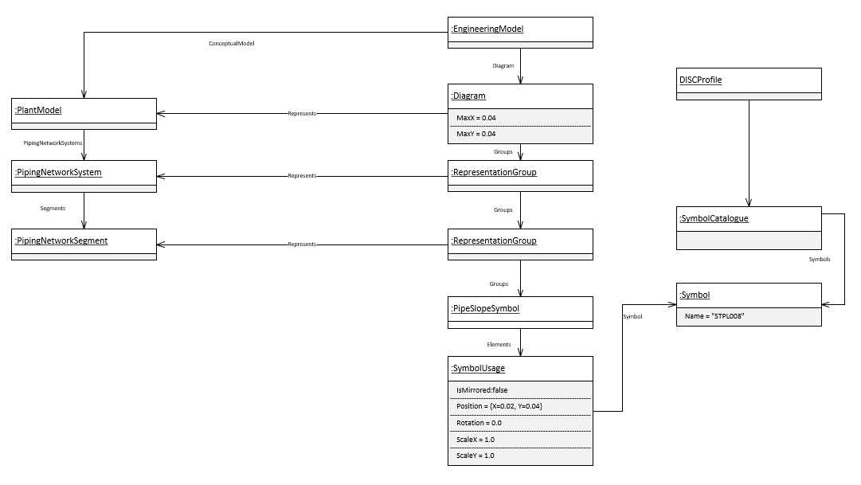
Figure 31: DEXPI Slope model example

Requirement Details:
- The pipeline slope graphic shall use the ‘PipeSlopeSymbol’ type as per the model example above.
- The pipeline slope graphic shall reference the SymbolRegistrationNumber ‘STPL008’ within the transfer file as per the model example above.
- The association between the PipingNetworkSegment and the pipeline slope graphic shall be provided in the DEXPI transfer file following the model example above.

Piping Flow Direction Arrow
Pipeline flow direction arrow graphic shall be used to represent the flow direction for the pipe.
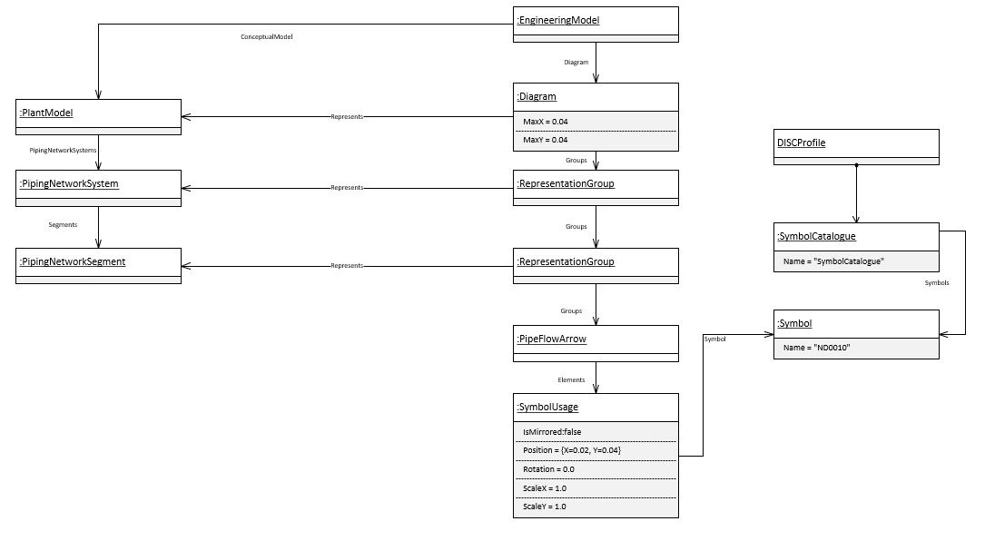
Figure 32: DEXPI Slope model example

Requirement Details:
- The pipeline flow arrow graphic shall use the ‘PipeFlowArrow’ type as per the model example above.
- The pipeline flow arrow graphic shall reference the SymbolRegistrationNumber ‘ND0010’ within the transfer file as per the model example above.
- The association between the PipingNetworkSegment and the pipeline flow arrow graphic shall be provided in the DEXPI transfer file following the model example above.

Radio-active target/source identification symbol
Radioactive symbol is used to identify a radioactive source or target object.
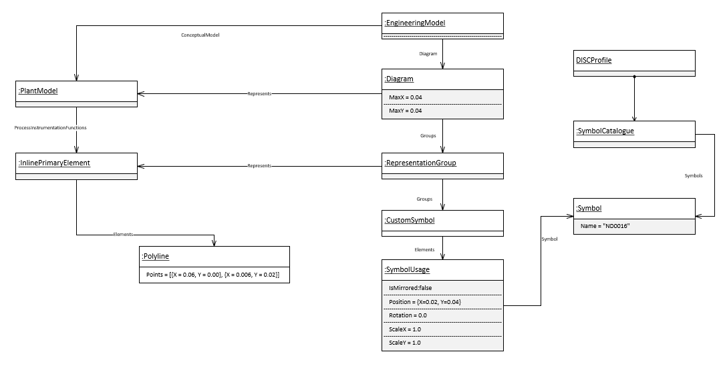
Figure 33: Radioactive symbol DEXPI model example

Requirement Details:
- The association between the ConceptualObject and the radioactive graphic shall be provided in the DEXPI transfer file following the model example above.

Graphics Items Without Symbol Reference
The following section details any special requirements regarding graphical elements that are not represented by a symbol.

Pipe
Pipe elements are represented in DEXPI as a connection between points: ConnectorLine InnerPoints and/or PipingNodePosition Position points.
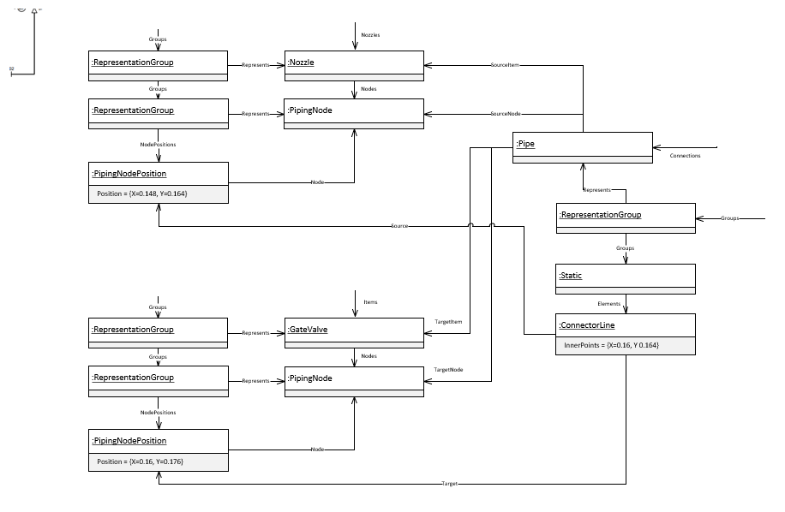
Figure 34: DEXPI Pipe with angle model example

Requirement Details:
- The PipingNodePosition Position point of the connected PipingNode shall represent a point on the PipingNodeOwner e.g. GateValve / Nozzle

Leader Lines
Leader lines are represented in DEXPI as a polyline with an ordered set of points depicting the start, end and any intermediate points of the line.
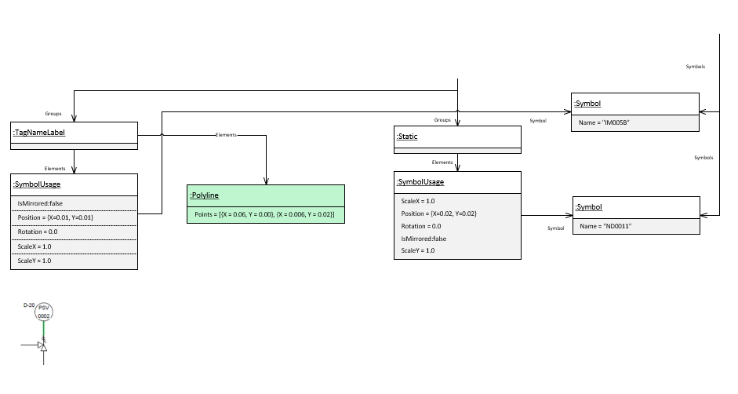
Figure 35: Leader line graphic representation example

Requirement Details:
- Leader lines shall be ‘owned’ by the label as shown above.

Elevation
Elevation is represented in DEXPI as a polyline with an ordered set of points depicting the start, end and any intermediate points of the line.
Example Ref:
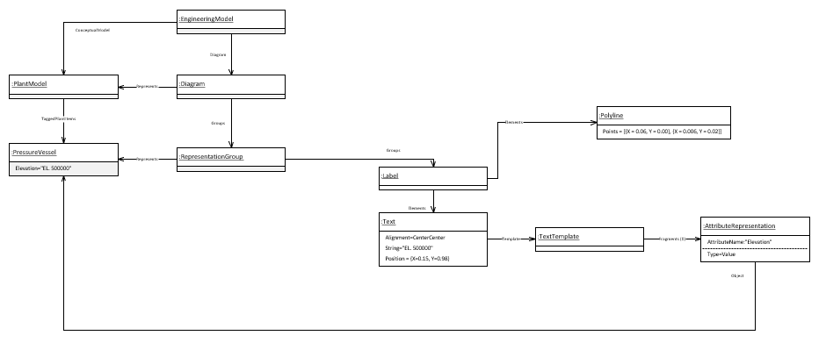
Figure 36: Elevation representation example

Requirement Details:
- Elevation labels shall be ‘owned’ by the appropriate class as shown above.

ANNEX A: PipingNetworkSegment topology details
PipingNetworkSegment Topology (Connection element)
Components within a PipingNetworkSegment are considered to be implicitly connected, by their main flow in and flow out connections points, in the order that they are represented in the PipingNetworkSegment. This ordering may differ between a P&ID and 3D model.

Each PipingNetworkSegment is a collection of PipingNetworkSegmentItems (e.g., PipingComponents such as Valves) and PipingConnections (e.g., Pipes) with common engineering properties that define a single process flow. Where there is a junction in the flow or a change of specification (e.g., piping class or nominal diameter), the PipingNetworkSegment will terminate.

A PipingNetworkSegment, as its SourceItem, will reference a Nozzle, PipingComponent, or PropertyBreak that it doesn’t contain or it will reference a FlowInPipeOffPageConnector that it contains.
Connection from :
Nozzle
PipingComponent
PropertyBreak

PipingNetworkSegment

…
PipingNetworkSegment

FlowInPipeOffPageConnector
…
Connection from :
FlowInPipeOffPageConnector

A PipingNetworkSegment, as its TargetItem, will reference a Nozzle, merging component (a PipingComponent such as a Tee) that it doesn’t contain or it will reference a PipingComponent, PropertyBreak, or FlowOutPipeOffPageConnector that it contains as its last component.
PipingNetworkSegment

PipingNetworkSegment
Connection to :
Nozzle
Merging component

…
PipeConnectorSymbol
Reducer
Splitting Component
…
Connection to :
PipingComponent, PropertyBreak
FlowOutPipeOffPageConnector

If the TargetItem of a PipingNetworkSegment is a contained PipingNetworkSegmentItem, the TargetNode of the PipingNetworkSegment is the main downstream PipingNode of this PipingNetworkSegmentItem, if applicable (i.e. the main flow out of the segment).

ANNEX B: Symbol Rotation and mirroring
The following table shows the rotation and mirroring of an example symbol and demonstrates that mirroring the base symbol (shown in RED) on the Y-axis and then rotating 180º provides the same result as if the base symbol had been mirrored on the X-Axis. ** scaling before rotation.
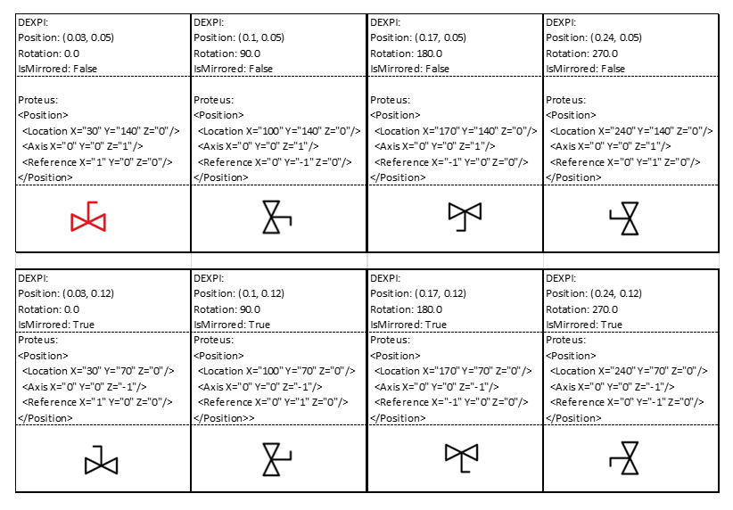
Figure 37: Symbol Rotation Attribute Example

Rotation and Mirroring Details
Example Ref:

- geometry unit: m (because SI base unit)
- axes and rotation like in SVG:
  - horizontal axis (x): left to right
  - vertical axis (y): top to bottom
  - rotation: in degrees, clockwise
- meaning of ShapeUsage attributes (note the order: in particular: scaling before rotation):
  - ScaleX, ScaleY: shape is scaled along x and y axis w.r.t. its origo (0, 0)
  - if IsMirrored: shape is mirrored at y axis (x=0)
  - Rotation: around (0, 0), in degrees, clockwise
  - Position: shape is translated such that its origo (0, 0) is translated to Position

ANNEX C: Signal conveying Line Types
When the SignalConveyingFunction is graphically represented the DEXPI transfer object shall include the following attributes:
Attribute | RDS | Transfer Value | Value RDS
AlarmValue | http://sandbox.dexpi.org/rdl/AlarmValue | Alarm value for HH/H/L/LL alarm when applicable. This shall be the alarm value from the connected PIF element. | 28 Barg
SignalConveyingFunctionTypeRepresentation | http://noaka.org/rdl/  SignalConveyingFunctionTypeRepresentationAssignmentClass | Line style type | ElectricalSignalConveying
Values for the SignalConveyingFunctionTypeRepresentation shall be in accordance with the table below:
Line / Signal | Name | DEXPI Type Representation
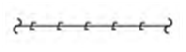 | Electrical Signal  Electrical Power | ElectricalSignalConveying
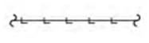 | Hydraulic Signal | HydraulicSignalConveying
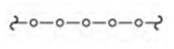 | Bus Signal  Data Link | BusSignalConveying
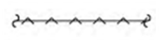 | Pneumatic Signal | PneumaticSignalConveying
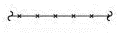 | Capillary | CapillarySignalConveying
 | Undefined Signal | UndefinedSignalConveying
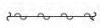 | Electromagnetic Guided Signal | ElectromagneticGuidedSignalConveying
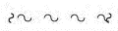 | Electromagnetic Unguided Signal | ElectromagneticUnguidedSignalConveying
 | Electrical Signal  Hidden Line | SignalConveying
Figure 38:ignalConveyingFunctionTypeRepresentation values

ANNEX D: Valve Label Details

The attributes available within valve labels shall be determined based on whether the valve symbol is used to show a manual valve or an on/off actuated or controlled valve. Attribute details for the valve label is defined in the symbol legend details (Ref: [5]) using the attribute formats below.

- Manual Valves
A space character shall be used between the trim and lock mechanism attributes as shown.
<ObjectDisplayName>
<NominalDiameter><VDS>
<TrimType> <LockMechanism>

- On/Off Actuated or Controlled Valves
A space character shall be used between the trim and lock mechanism attributes as shown.
<NominalDiameter><VDS>
<TrimType> <LockMechanism>
Additional Notes:
- Valve Normal Position is no longer required to be shown in the label. Normal Position will be indicated by the symbol used e.g. black closed , white open
- Failure action is required to be shown in the label for the actuator if available Ref: [5]
- “Barrier information is not required in the label as this will be shown as part of the graphic” referring to DIB valves (examples below) and “Barrier information” the DP and SR notations. The following DIB valves will be added to the DISC DEXPI symbol legend soon.
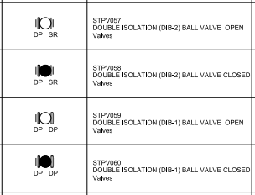
Figure 39: Valve Barrier variants

